**Lab 02 - ingest data into Customer Insights**

You've been selected as the project manager for the implementation of Dynamics 365 Customer Insights at Contoso Coffee. As an experienced project manager, you devise the following plan:

* Ingest data from highest priority data sources from within the business:
  + Point-of-Sale (POS)
  + Loyalty data
  + E-commerce customers and web purchases
* Configure a unified customer profile from ingested data.

**Learning objectives**

At the end of these exercises, you'll be able to accomplish the following objectives:

* Sign up for a Dynamics 365 Customer Insights trial.
* Ingest siloed data sources.

**Exercise 1 - Ingest data into Customer Insights**

In this exercise, you'll become familiar with ingesting data from multiple sources.

As Project Manager for Contoso Retail, you've already identified that key sources of data include e-commerce customers, online purchases, in-store Point of Sales purchases, and data from the Contoso Retail loyalty card scheme.

Although Customer Insights has connectors to over 30 data sources and applications (including Dynamics 365 and Microsoft Dataverse), for this lab, you'll be using the *Text/CSV* connector.

**Data Sources**

| **Item** | **Description** | **Format** | **URL** |
| --- | --- | --- | --- |
| eCommerce Contacts | Extract of customers who have made an online purchase | Text/CSV | [Link](https://ciaddata.blob.core.windows.net/ciad-sample-data/Contact.txt) |
| Loyalty Scheme | Extract of customers who have signed up for the Contoso Retail Loyalty Card scheme | Text/CSV | [Link](https://ciaddata.blob.core.windows.net/ciad-sample-data/Customer-Loyalty.txt) |
| Online Purchases | Extract of purchases made through the Contoso Retail website | Text/CSV | [Link](https://ciaddata.blob.core.windows.net/ciad-sample-data/OnlinePurchases.txt) |
| POS Purchases | Extract of in-store purchase detail | Text/CSV | [Link](https://ciaddata.blob.core.windows.net/ciad-sample-data/POSPurchases.txt) |
| Website Reviews | Online website reviews from customers | Test/CSV | [Link](https://ciaddata.blob.core.windows.net/ciad-sample-data/WebsiteReviews.txt) |

### Task 1 - Sign-in to Customer Insight

1. Sign-in to Customer Insights (<http://home.ci.ai.dynamics.com>) and select your

Environment (Contetech) from the drop-down in the top right-hand corner.

1. Explore the left-hand menu options to familiarise yourself with the navigation.

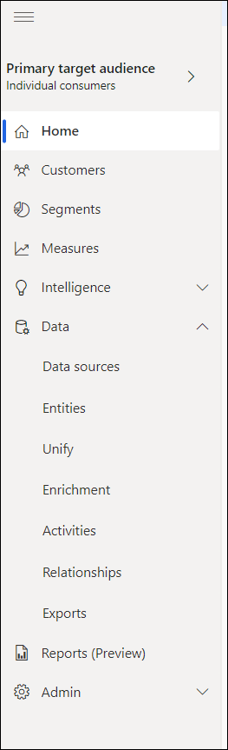

**Home:** Home Page

**Customers:** View cards for unified Customer Profiles

**Segments:** Define Segments: Cohorts of Customers based on similar demographic, transactional or behavioural attributes. Use these for targeted marketing, utilising previously siloed data.

**Measures:** Define key Business and Customer KPIs.  
Such as Customer Lifetime Value, Average Purchase Value and Frequency, CSAT and identify high-value customers.

**Intelligence:** Here you can add custom Azure machine learning models to make predictions on your unified customer data.

**Data**: Ingest siloed demographic, transactional of behavioural data and map, match and merge into a Unified Customer Profile. View your entities and define activity types and their relationships to your customers.

**Enrichment:** Go beyond your unified profile and enrich customer profiles with Microsoft Proprietary Data from the Microsoft Graph. Unlock data on affinities for hundreds of brands and dozens of interest-categories. These affinities are extracted for profiles that might be like your customers.

**Admin:** Administer System, Security and Connections for Customer Segments.

**Task 2 - Ingest customer data from an e-commerce platform**

1. Sign into Customer Insights - <http://home.ci.ai.dynamics.com> with your Office 365 tenant credentials and select your **Environment** from the drop-down menu in the upper-right corner.

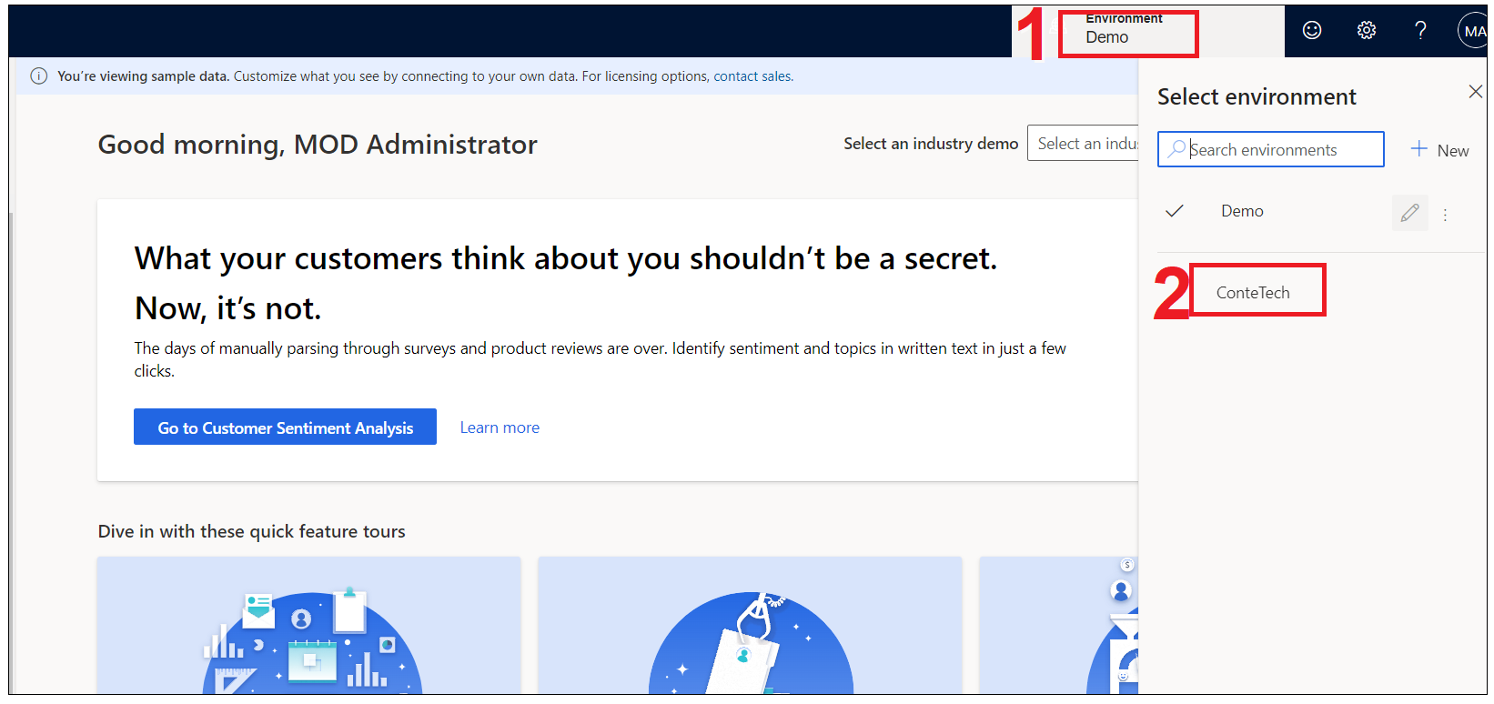

1. Within Customer Insights, expand **Data** on the left menu and then select **Data sources** and then select **Add Data Source**.

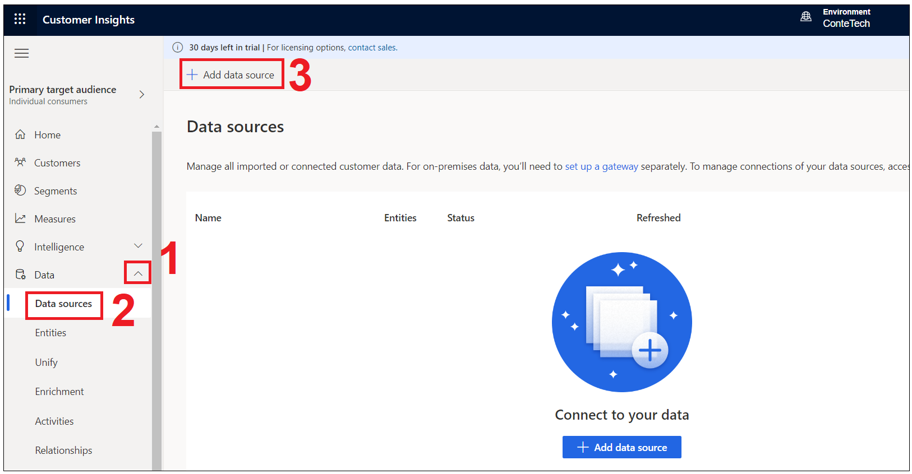

1. Select **Microsoft Power Query**, and in the **Save data source as** field, enter **eCommerce**, and then select the **Next** button.

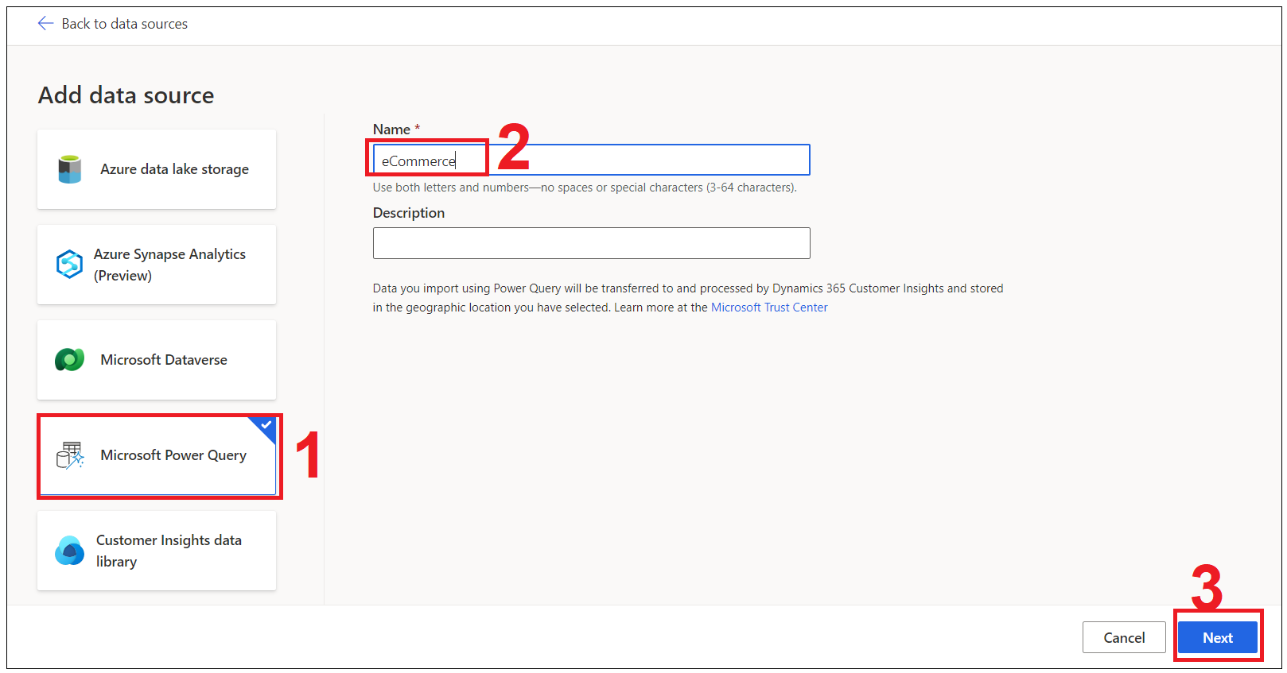

1. You'll be presented with a view of data source connectors that Customer Insights is able to ingest. Note the connector types that are available, including Dataverse. Select the **Text/CSV** connector.

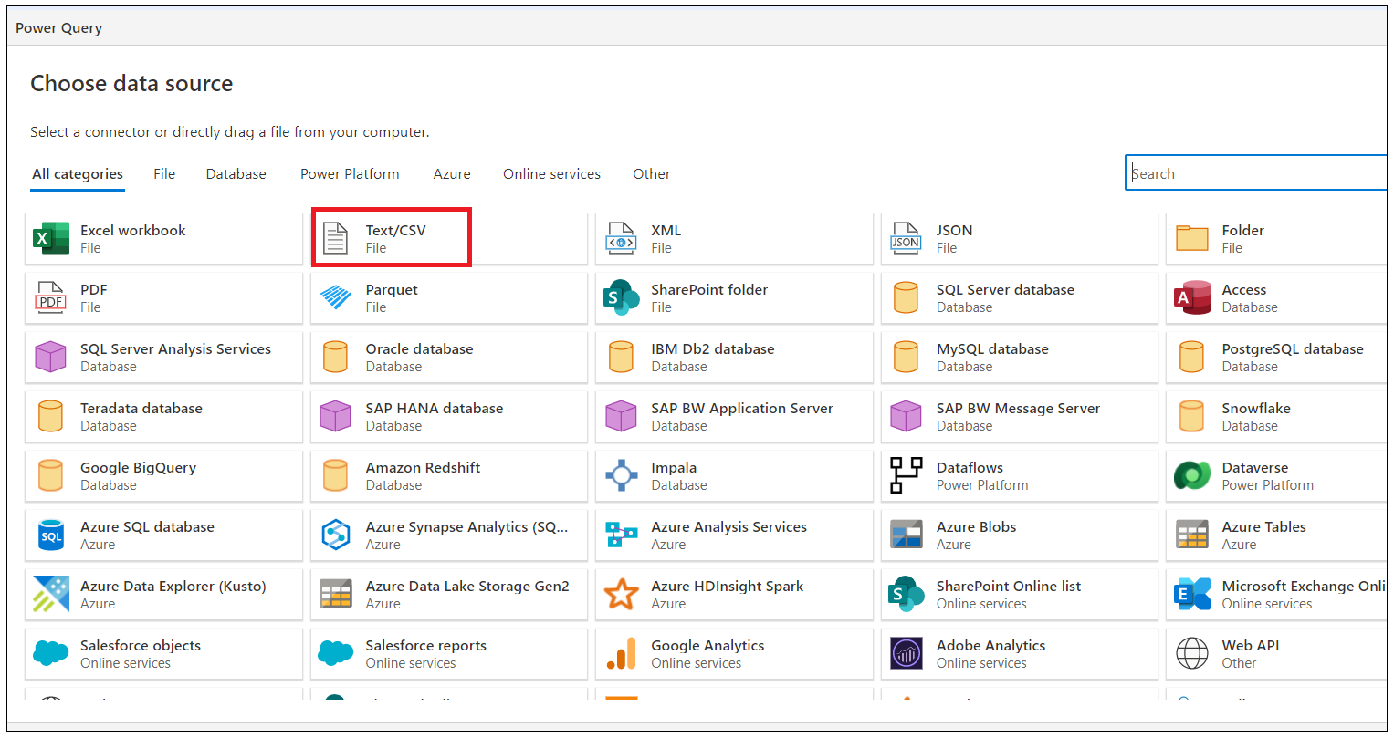

1. Enter the URL for the Azure BLOB named <https://aka.ms/ciadclasscontacts>, and then select **Next**. (You can find the URL in the table under the introduction to this lab.)

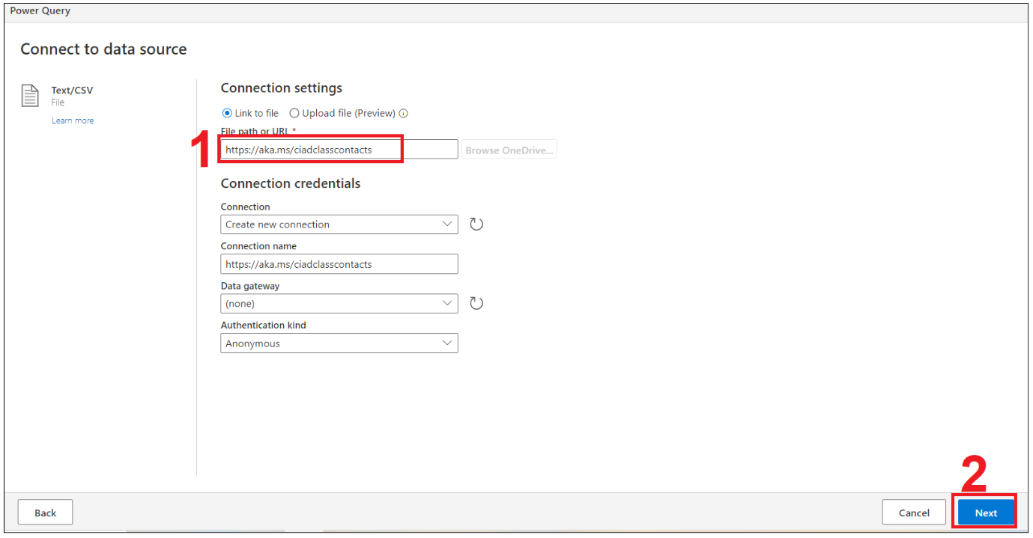

1. You'll now see the **Preview File Data** screen. Here you can change the delimiter, file origin type or what data is being used for the data type detection. You can select the **Transform data** button.

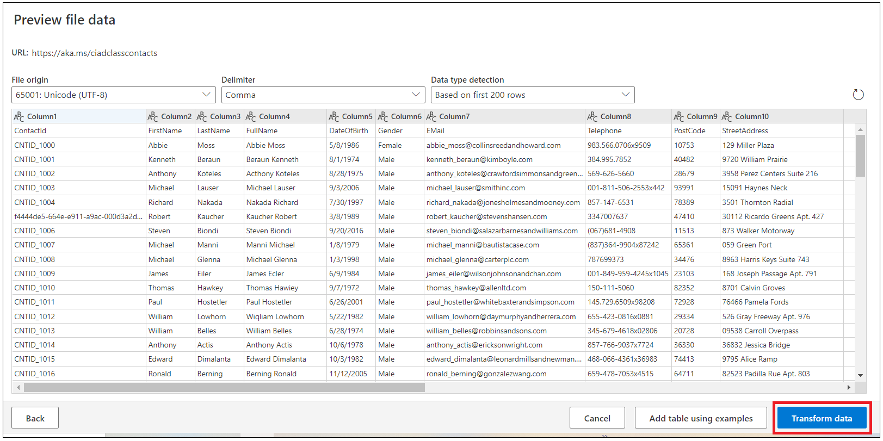

1. You should now see that the data from the source is tabulated. Now, you can configure the datatypes and formats for the data that you ingest. Notice that the column heading has appeared in the first row of the data. To correct this issue, select **Transform table** and then select **Use first row as headers**.

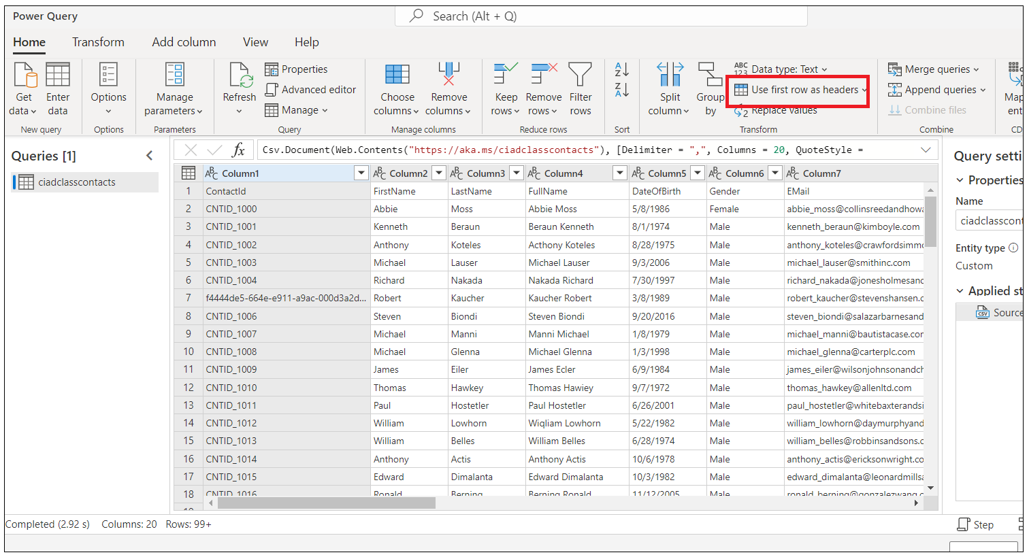

1. Because you have ingested data from a Text/CSV source, all columns have defaulted to a Text datatype. To successfully ingest and model the data, you can set the datatype for non-text columns.
2. To change the datatype, select the **ABC** icon within the column heading.

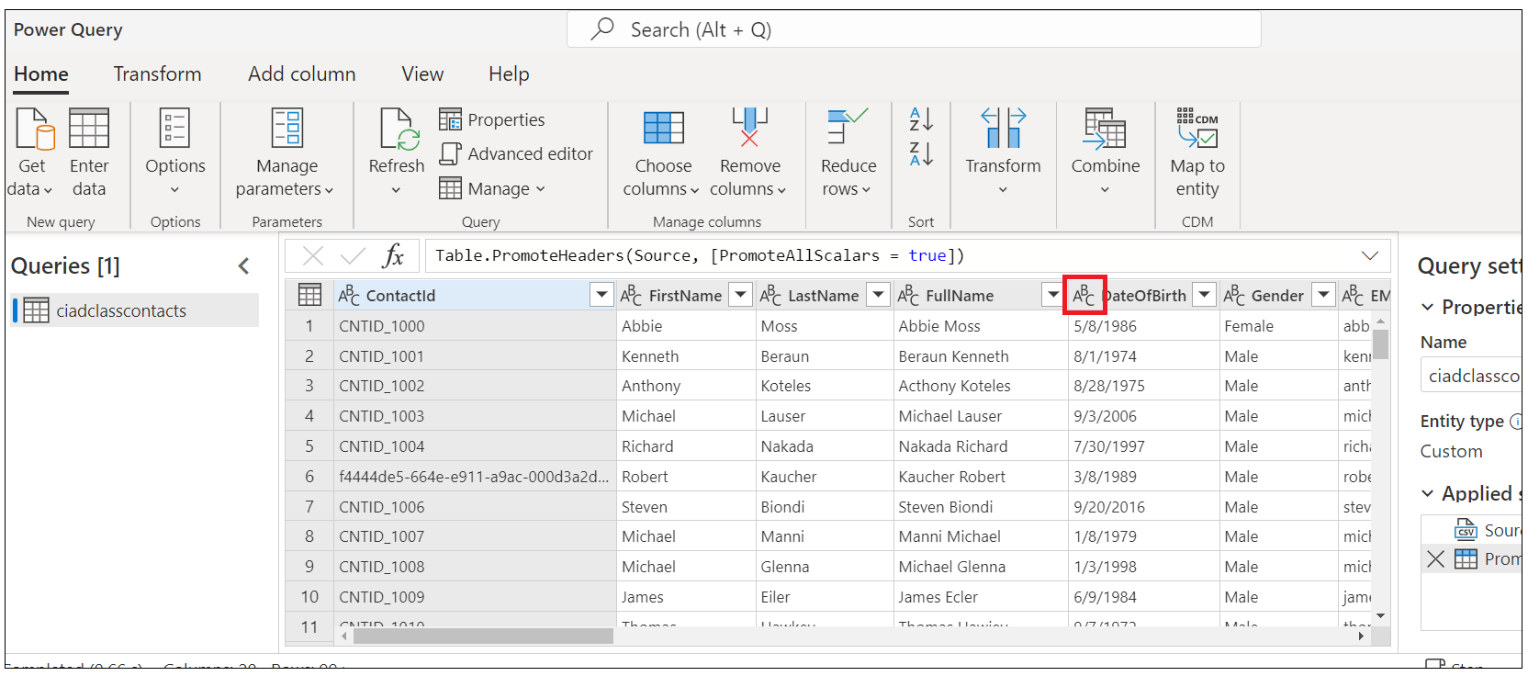

1. Update the datatype for the columns that are listed in the following table.

| **Column heading** | **New datatype** |
| --- | --- |
| DateOfBirth | DateTime |
| CreatedOn | Date/Time/Zone |

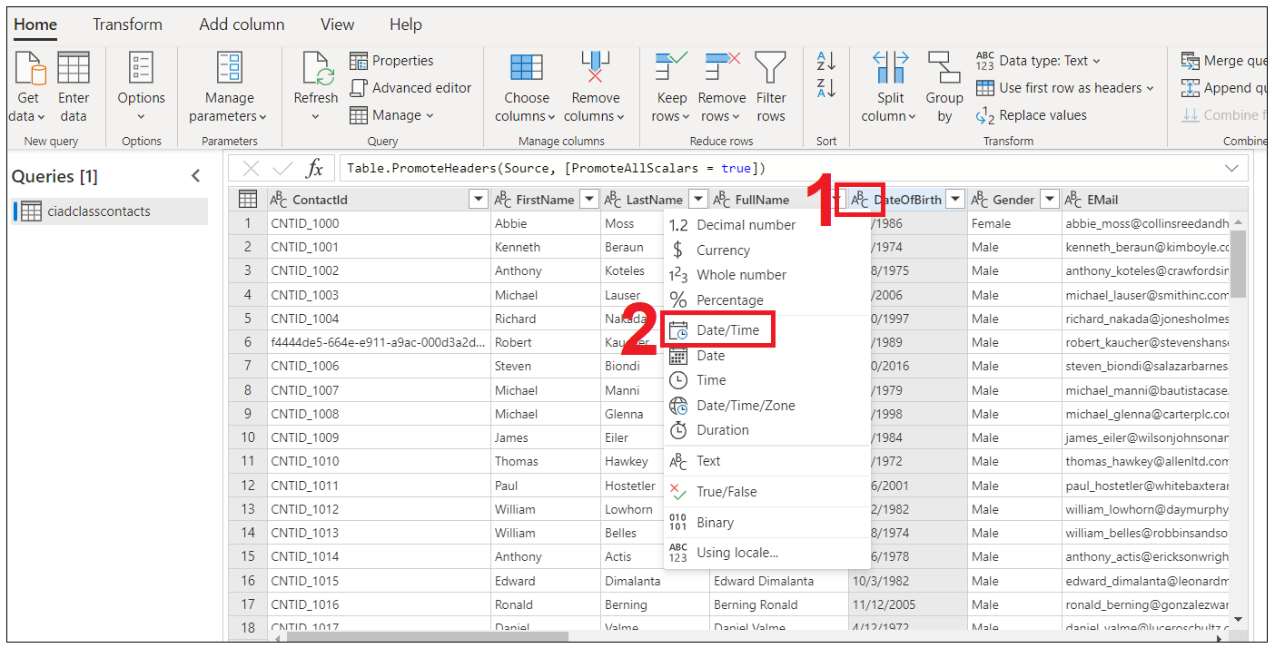

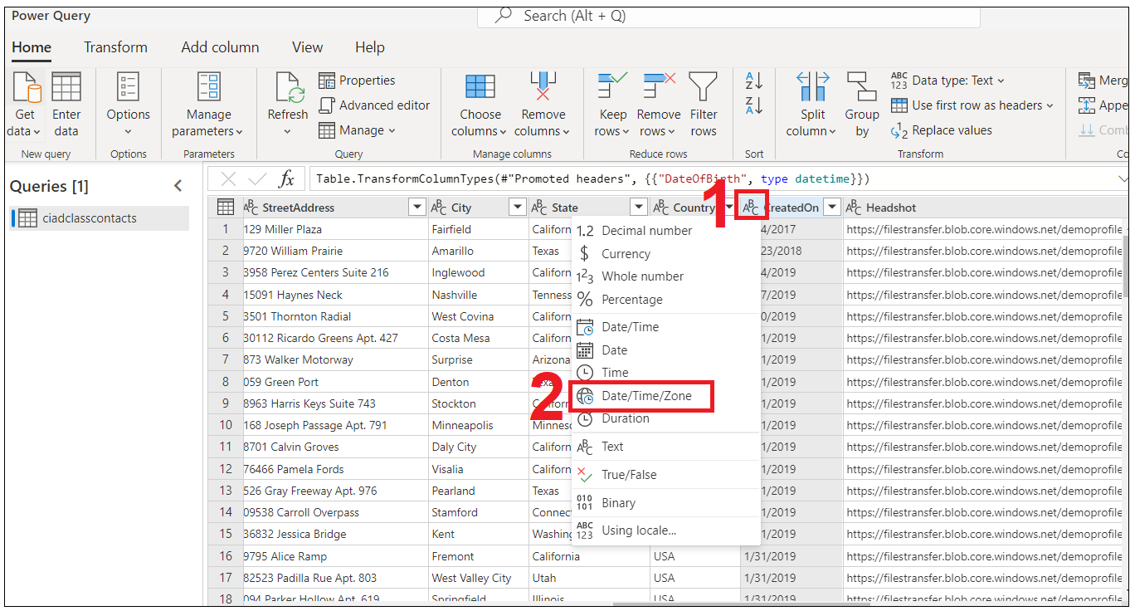

1. In the **Name** field on the right pane, rename your data source from **Query** to **eCommerceContacts** and then click **Next**.

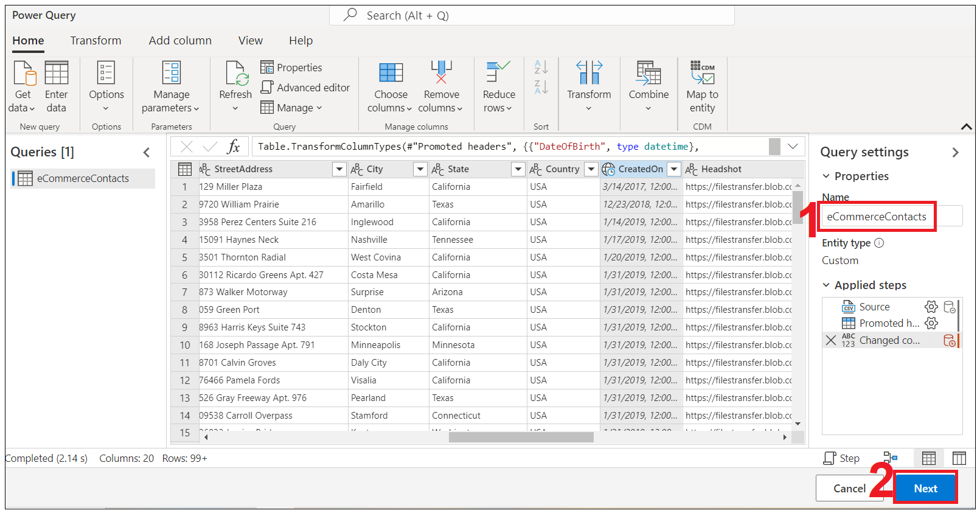

1. Select **Refresh manually** and then click on **Save**.

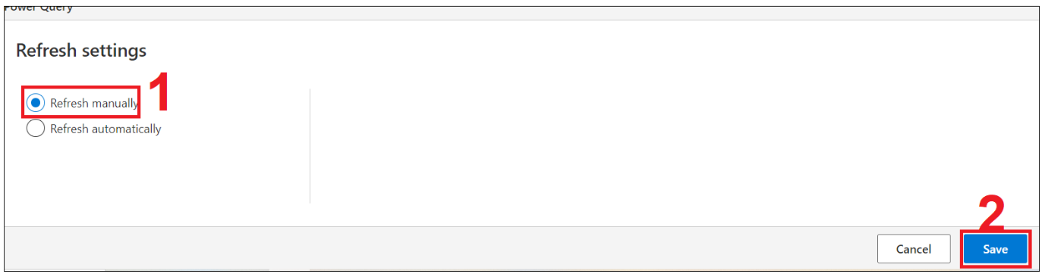

Congratulations! You've now successfully ingested your first data source into Customer Insights.

**Note**

One thing to be aware of, column names can only contain letters, numbers, and underscores. They cannot contain a space and must begin with a letter. If you have data where column name(s) have a space or do not begin with a letter you will want to fix that either within Power Query or before the data is brought into Customer Insights.

**Task 3 - Ingest online purchase data**

In this next task, you'll ingest Online Purchase data, which represents purchases made through the Contoso Coffee website.

1. Within Customer Insights, expand **Data** on the left menu and then select **Data sources**.

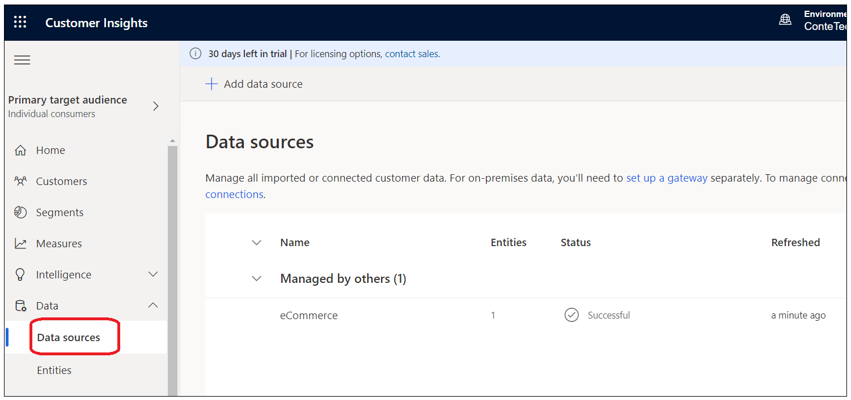

1. You should see your **eCommerce** data source. Under **Actions**, select the three vertical dots and then select **Edit**.

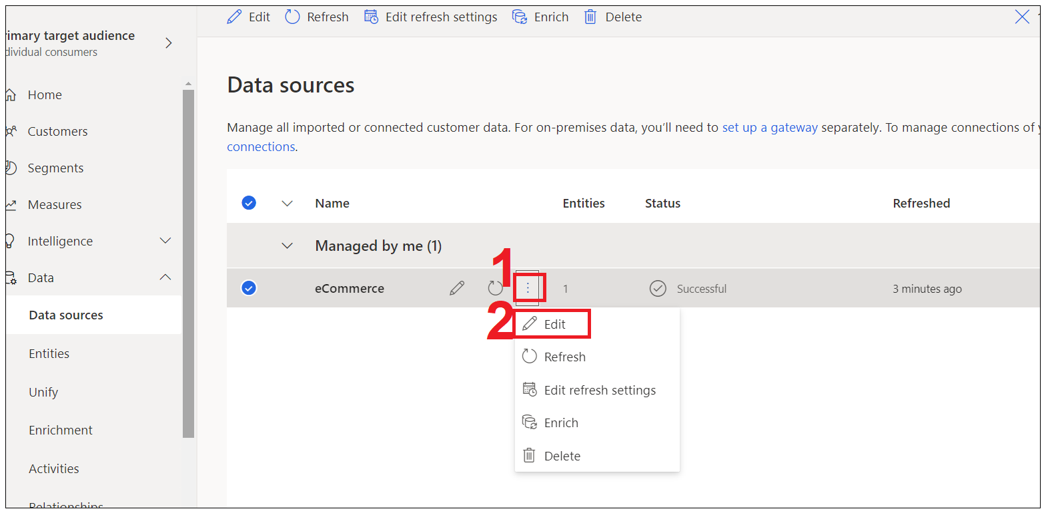

1. Without changing anything, click **Next**.

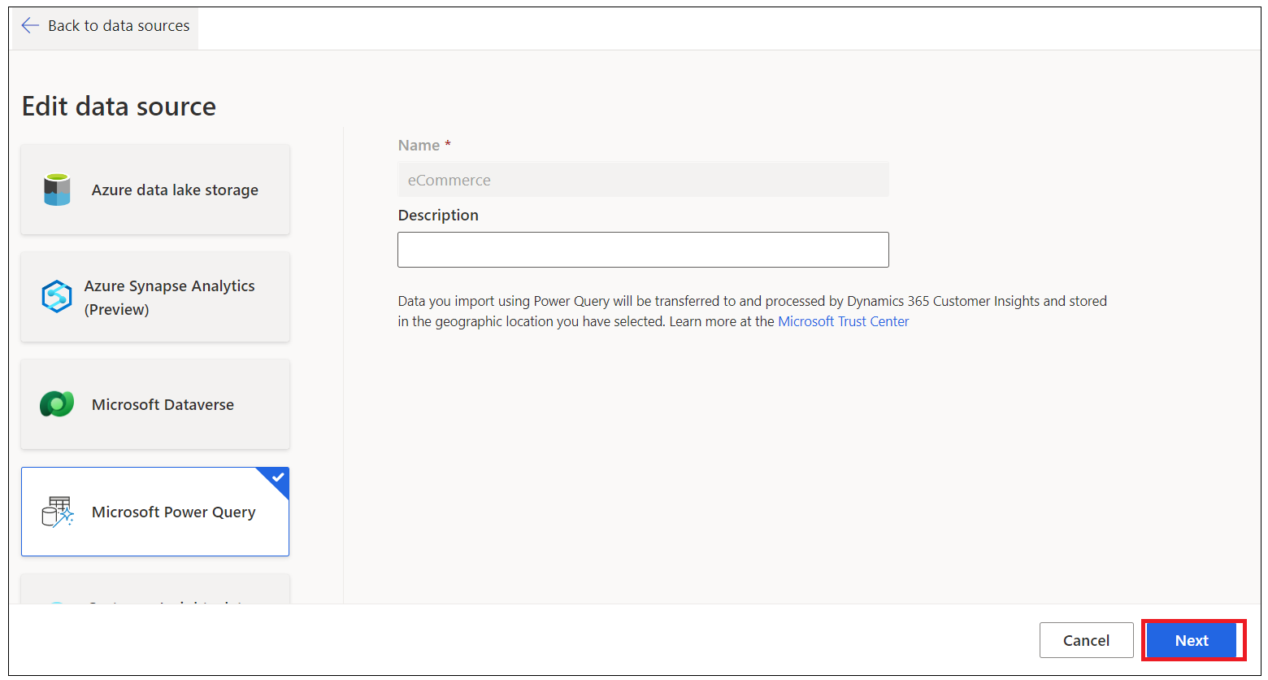

1. You should be presented with the view of the **eCommerceContacts** data that you ingested in Task 1. In the action menu, select **Get data**.

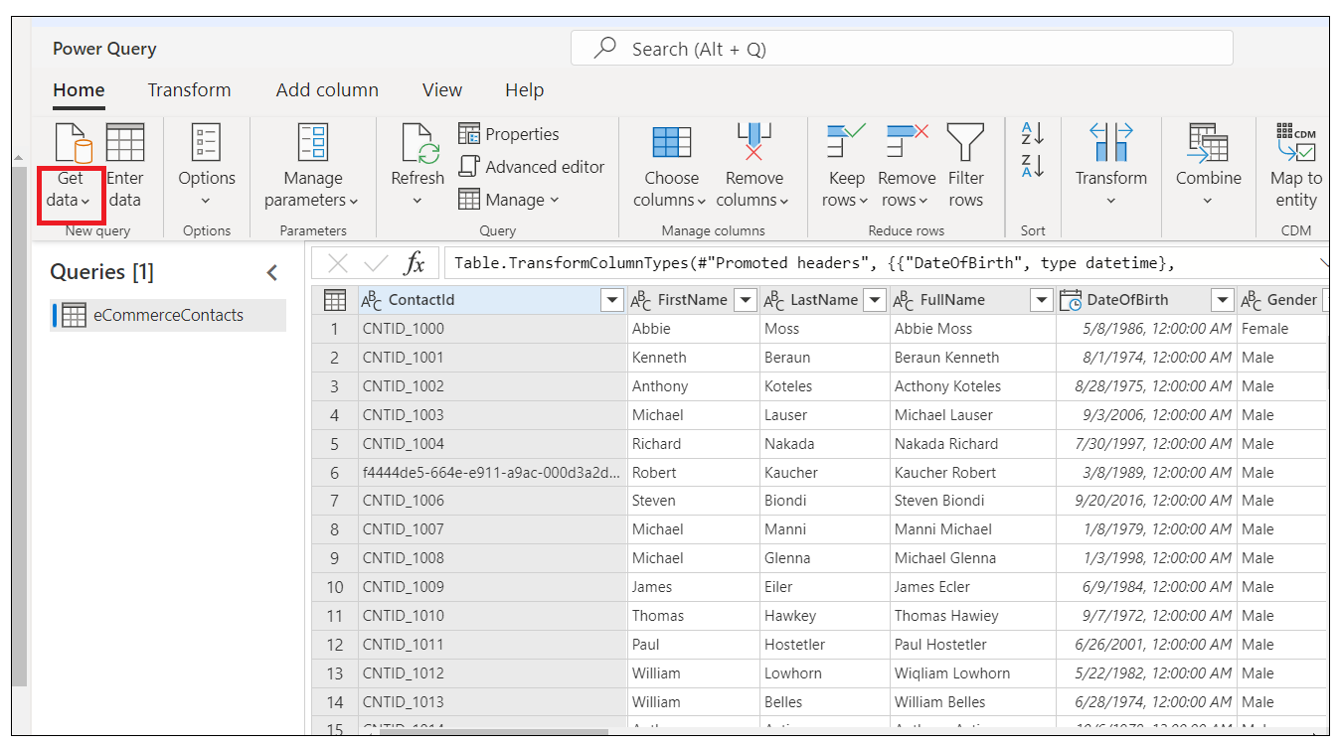

1. You'll be presented with a view of data source connectors that Customer Insights is able to ingest as you did in Task 1. Select the **Text/CSV** connector.

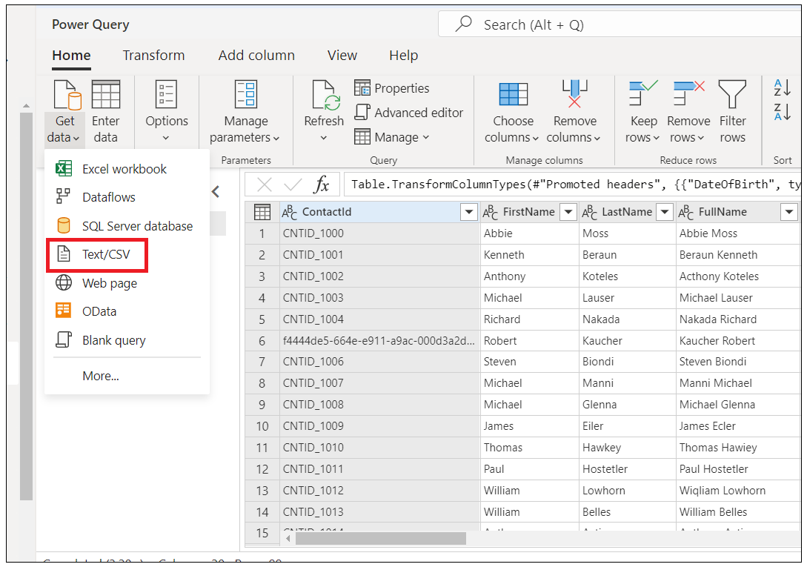

1. Enter the URL for the Online Purchases data, <https://aka.ms/ciadclassonline> data and then select **Next**.

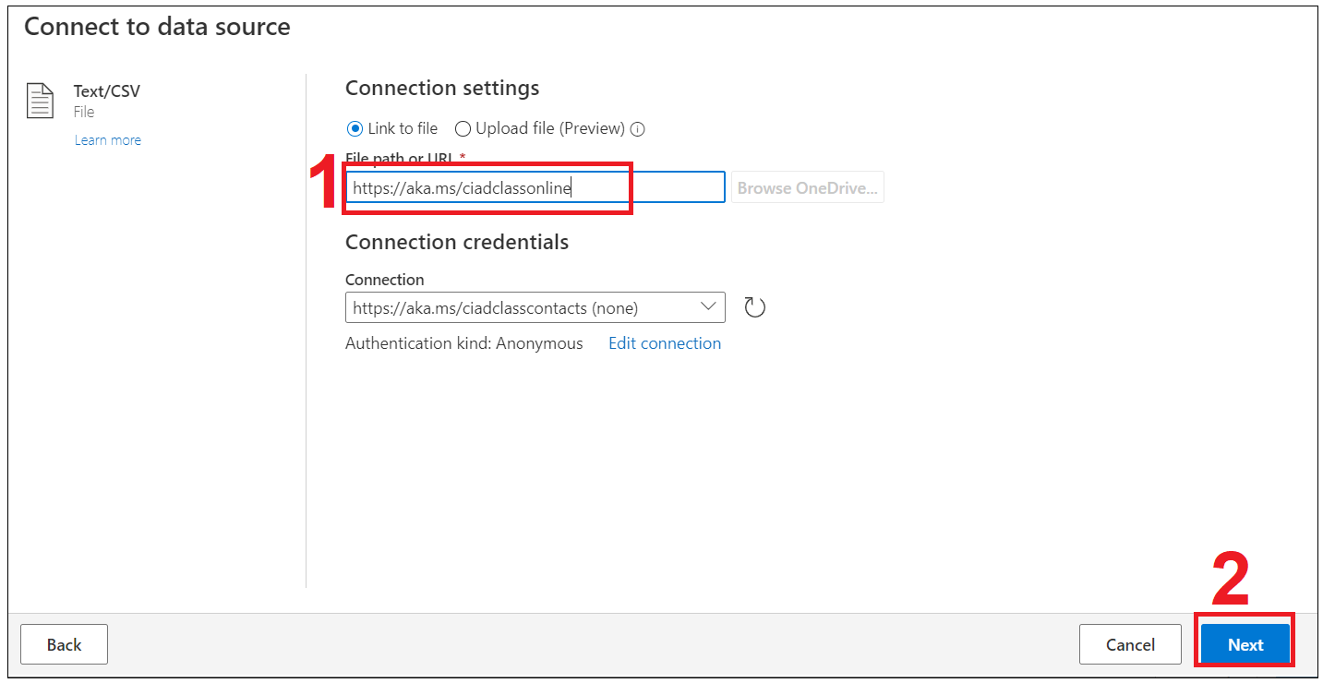

1. You'll now see the **Preview File Data** screen. Here you can change the delimiter, file origin type or what data is being used for the data type detection. You can select the **Create** button

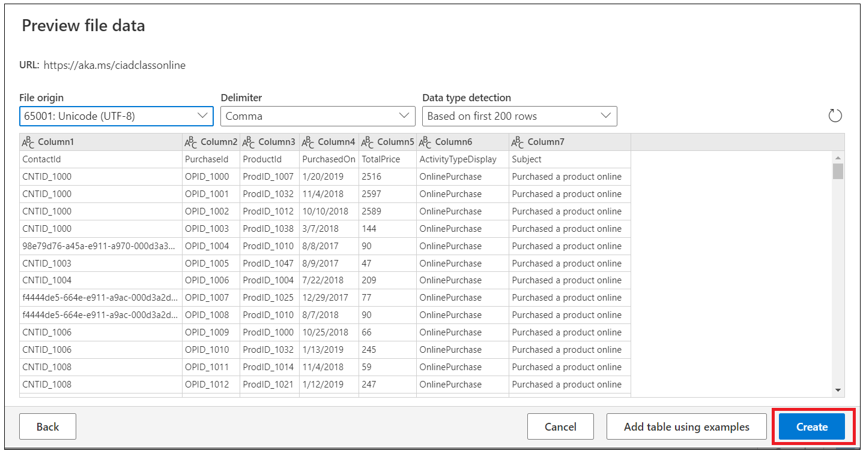

1. Select  **Use first row as headers**.

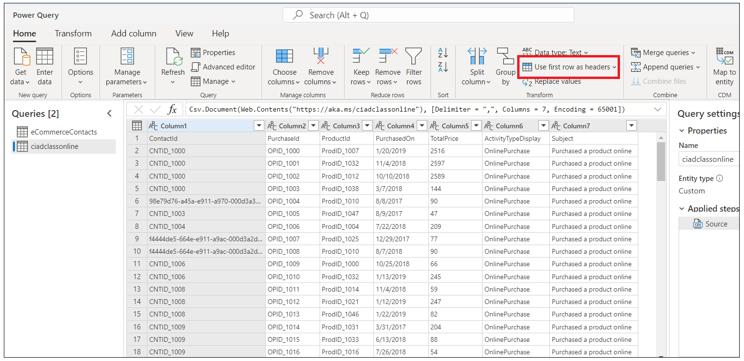

1. Update the datatypes for the columns in the following table as shown in below images..

| **Column heading** | **New data type** |
| --- | --- |
| PurchasedOn | Date/Time/Zone |
| TotalPrice | Currency |

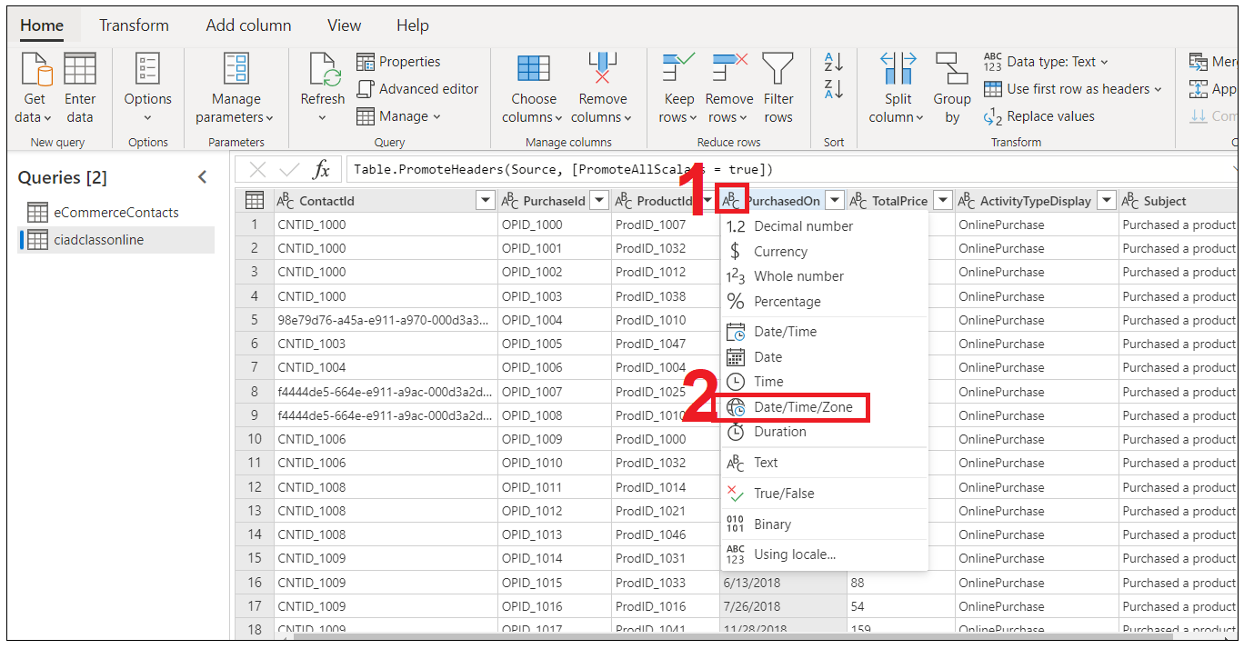

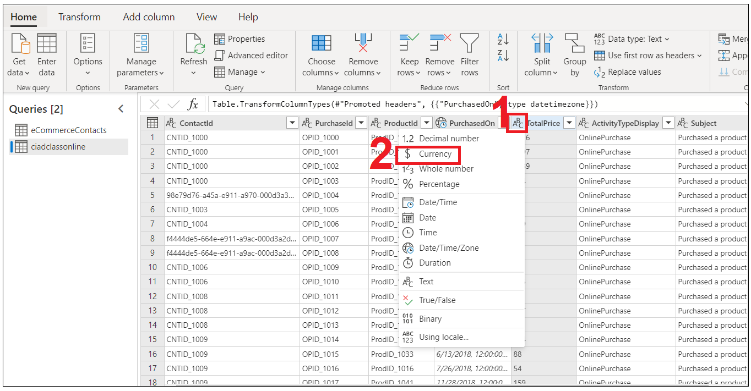

1. Name your query **eCommercePurchases** and then select **Save**.

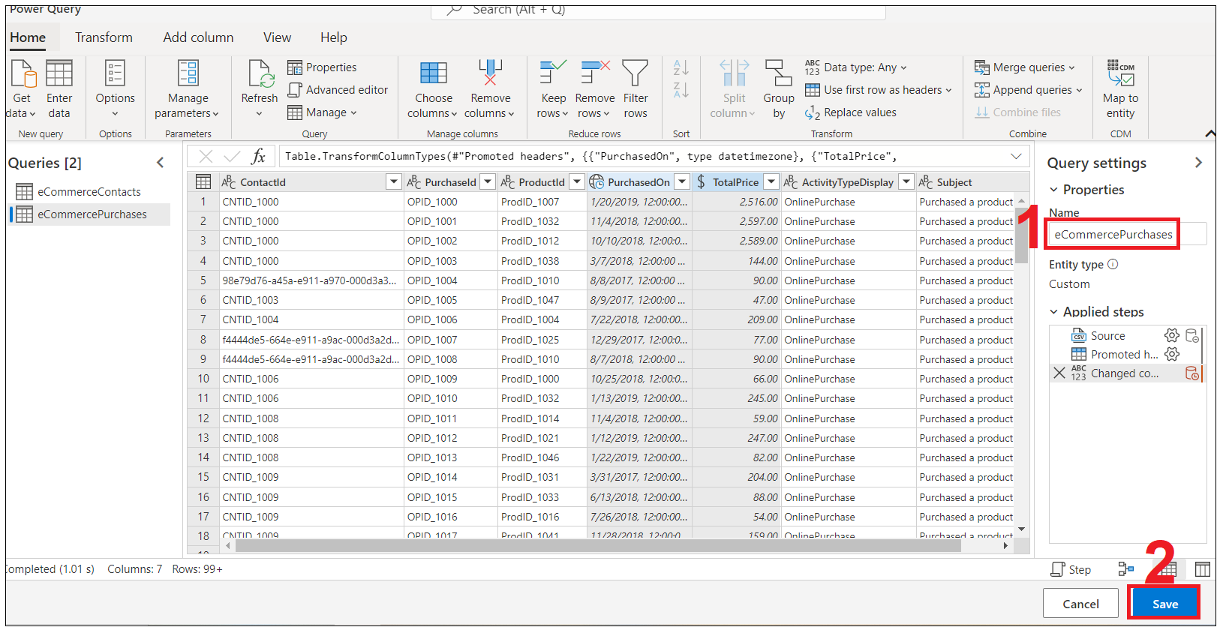

**Task 4 - Ingest customer data from loyalty scheme, point of sale purchases, and website reviews**

1. Within Customer Insights, expand **Data** on the left menu and select **Data Sources**.Select **Add Data Source**.

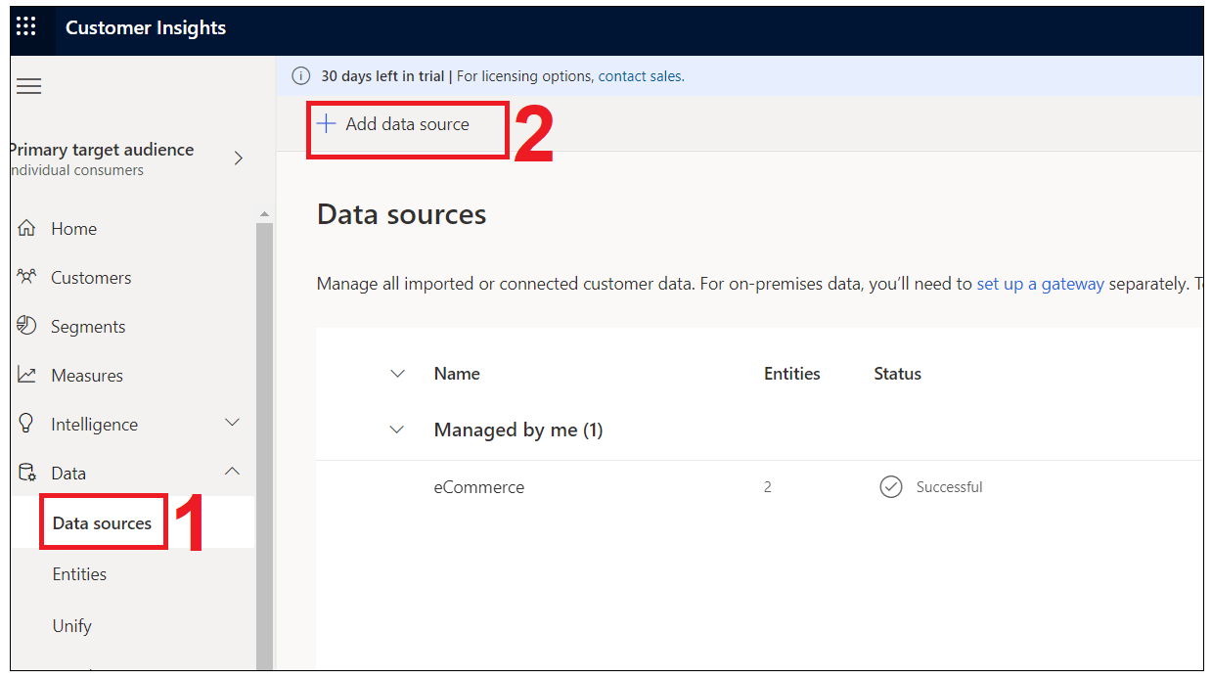

1. Select **Microsoft Power Query**, in the Save data source as field, enter **Loyalty** and select the **Next** button.

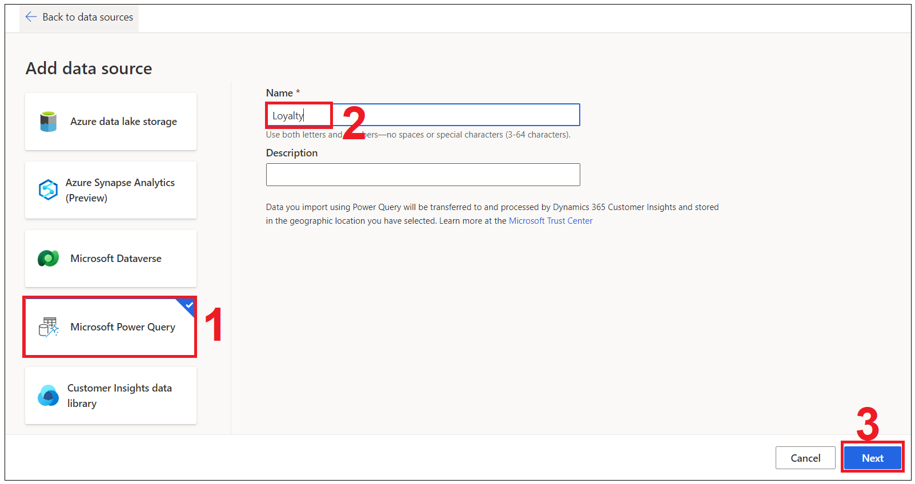

1. You'll be presented with a view of data source connectors that Customer Insights is able to ingest. Take note of the connector types available. Select the **Text/CSV** Connector.



1. Enter the URL for [Loyalty Contacts](https://ciaddata.blob.core.windows.net/ciad-sample-data/Customer-Loyalty.txt) and select **Next**.

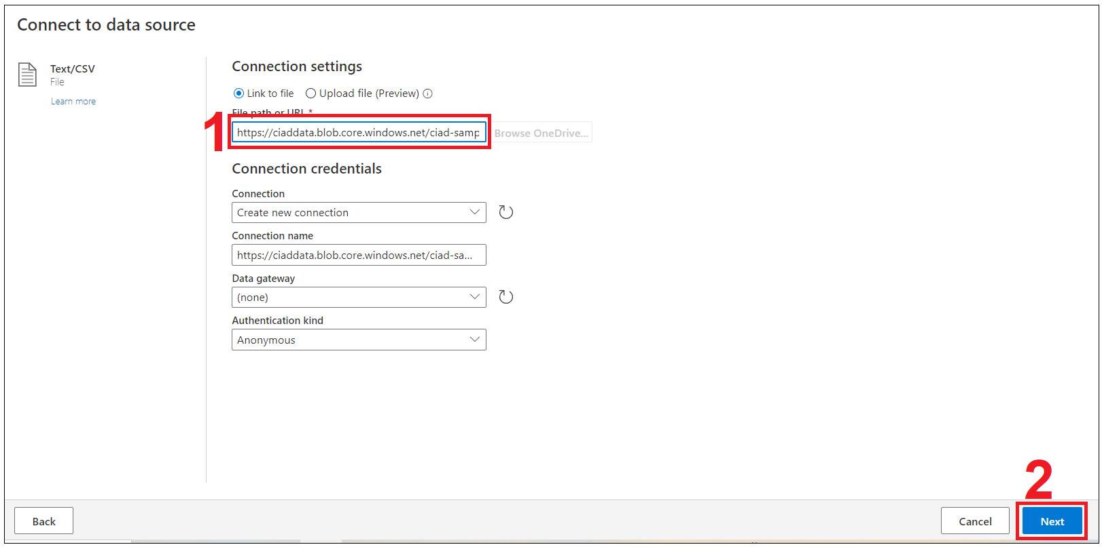

1. You'll now see the **Preview File Data** screen. Here you can change the delimiter, file origin type or what data is being used for the data type detection. You can select the **Transform data button**.

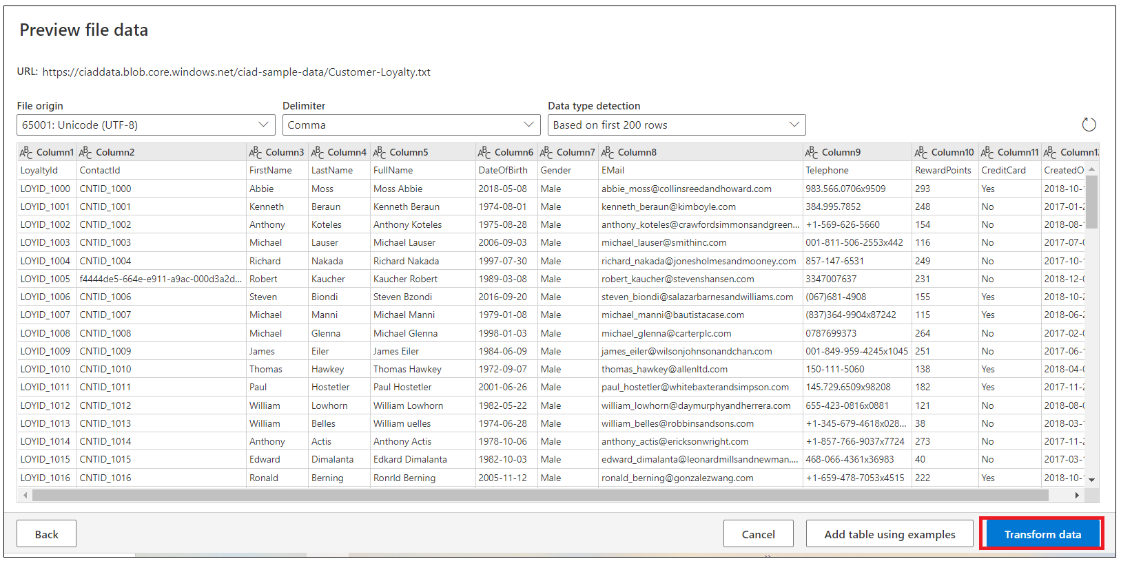

1. You should now see the data from the source tabulated. Here you can configure the datatypes and formats for the data you ingest.
2. You'll notice that the column heading has appeared in the first row of the data. To correct this, select  **Use First Row as Headers**.

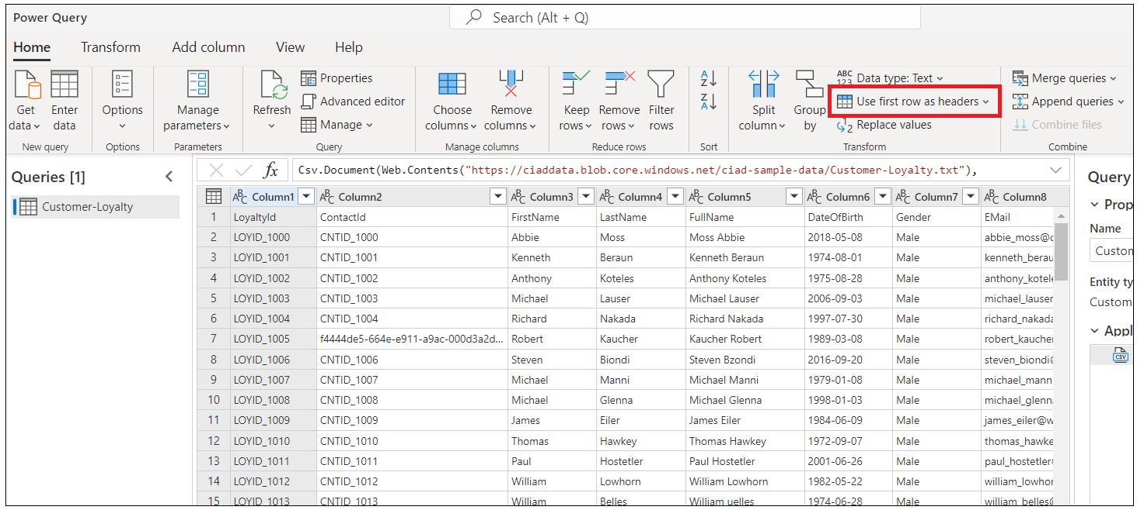

1. Because we have ingested data from a Text/CSV source, all columns have been defaulted to a ‘Text’ Data Type. To successfully ingest and model the data, we can set the datatype for non-text columns.
2. To change the datatype, select the **ABC** icon within the column heading. Update the datatype for the columns listed below.
3. Use the first row as column headings.

| **Column heading** | **New data type** |
| --- | --- |
| DateOfBirth | Date/Time |
| RewardPoints | Whole Number |
| CreatedOn | Date/Time/Zone |

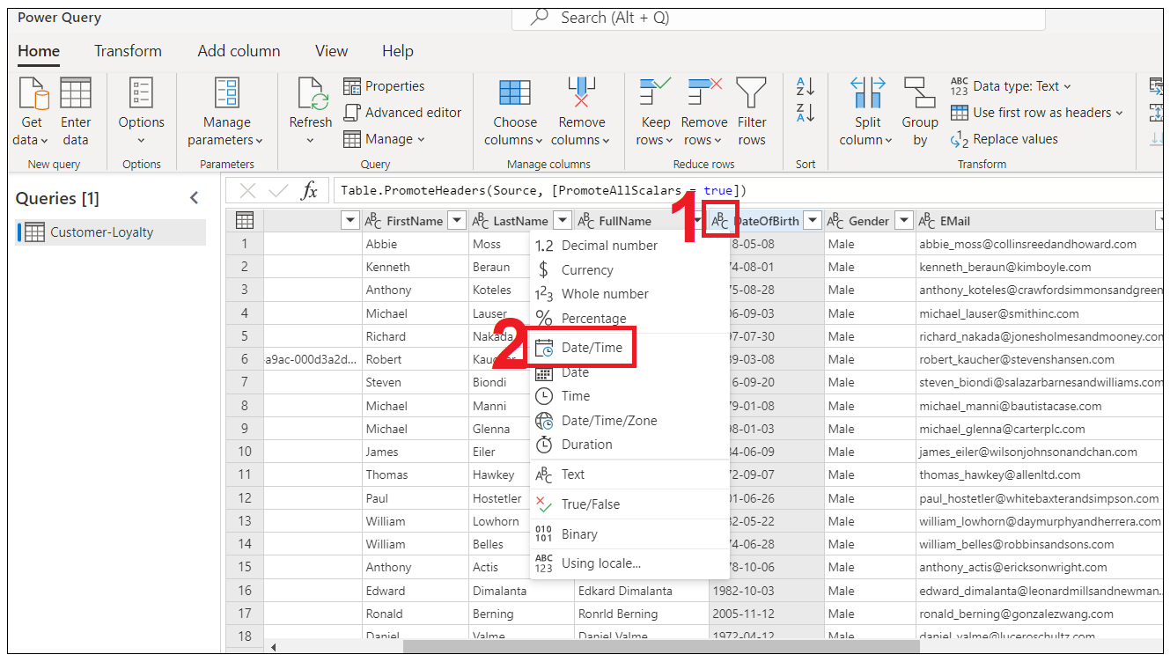

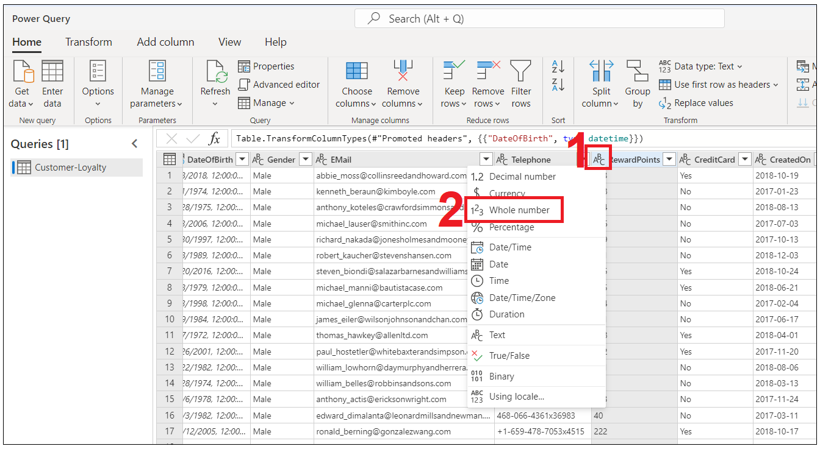

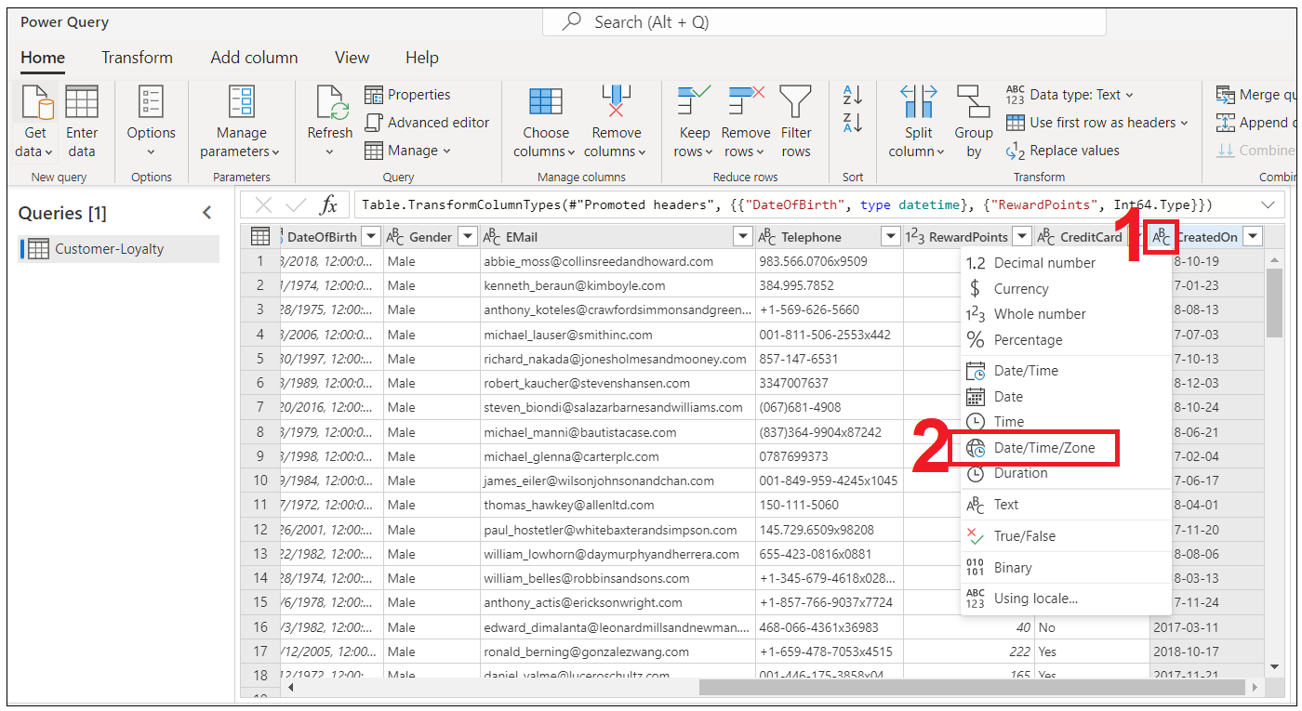

1. In the **Name** field on the right-hand pane, rename your data source from **Query** to **loyCustomers** then select **Next**.

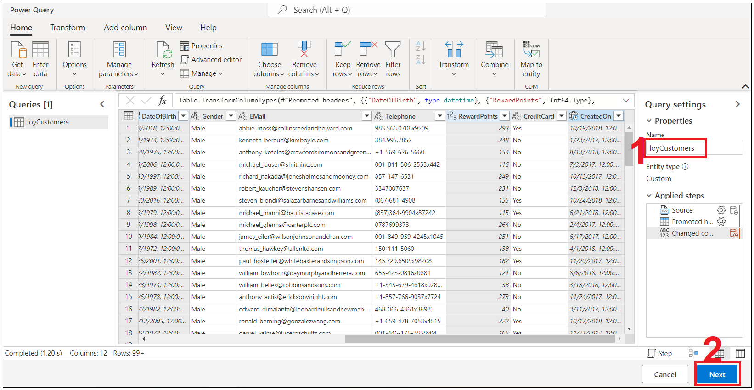

1. Select **Refresh manually** and then click on **Save**.

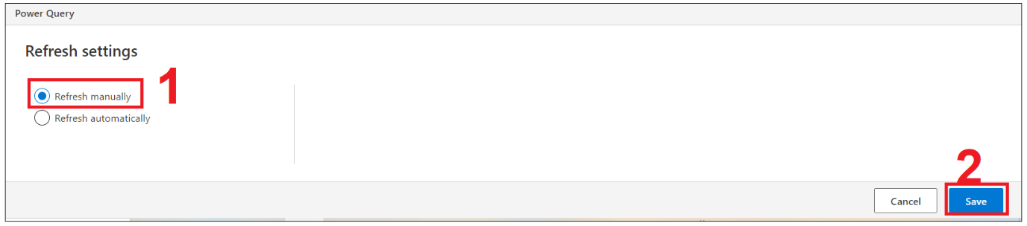

**Task 5 - Ingest Customer Data**

1. Within Customer Insights, expand **Data** on the left menu and select **Data Sources**.Select **Add Data Source**.

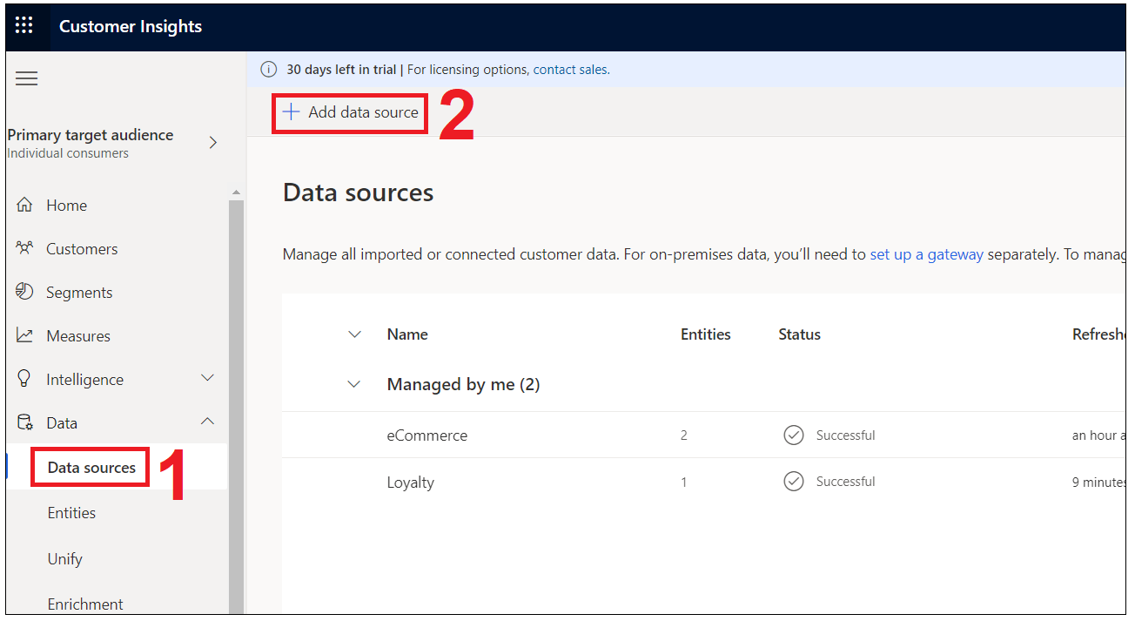

1. Select **Microsoft Power Query,** in the **Save data source as** field, enter **PoS** then select **Next**.

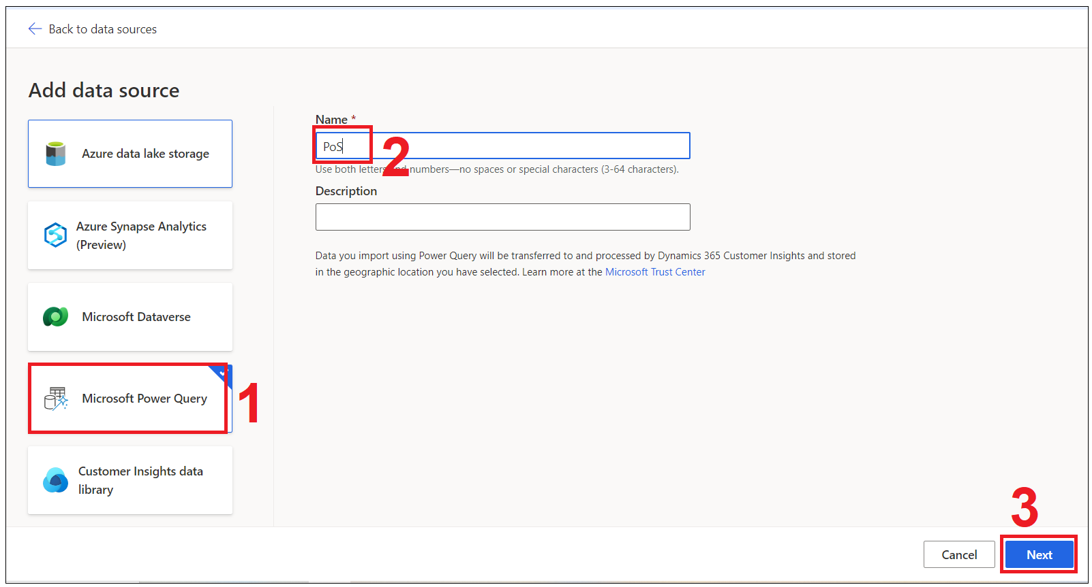

1. You'll be presented with a view of data source connectors that Customer Insights is able to ingest. Take note of the connector types available. Select the **Text/CSV** Connector.



1. Enter the URL for PoS Purchases <https://aka.ms/ciadclasspos> and then click **Next**.

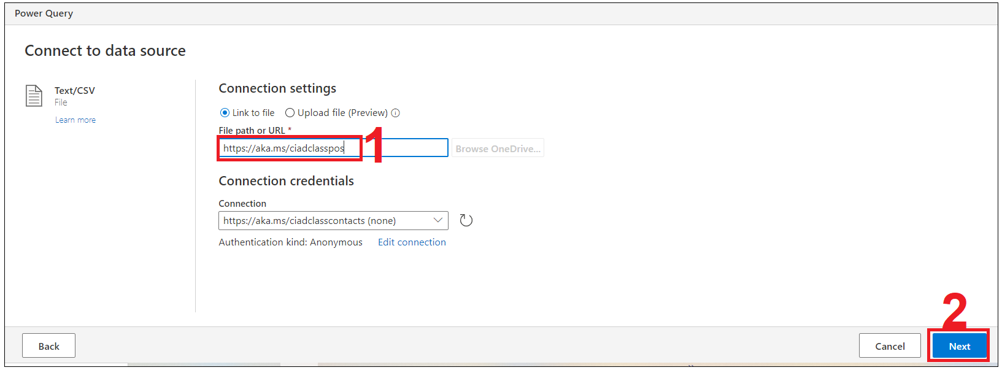

1. You'll now see the **Preview File Data** screen. Here you can change the delimiter, file origin type or what data is being used for the data type detection. You can select the **Transform data button**.

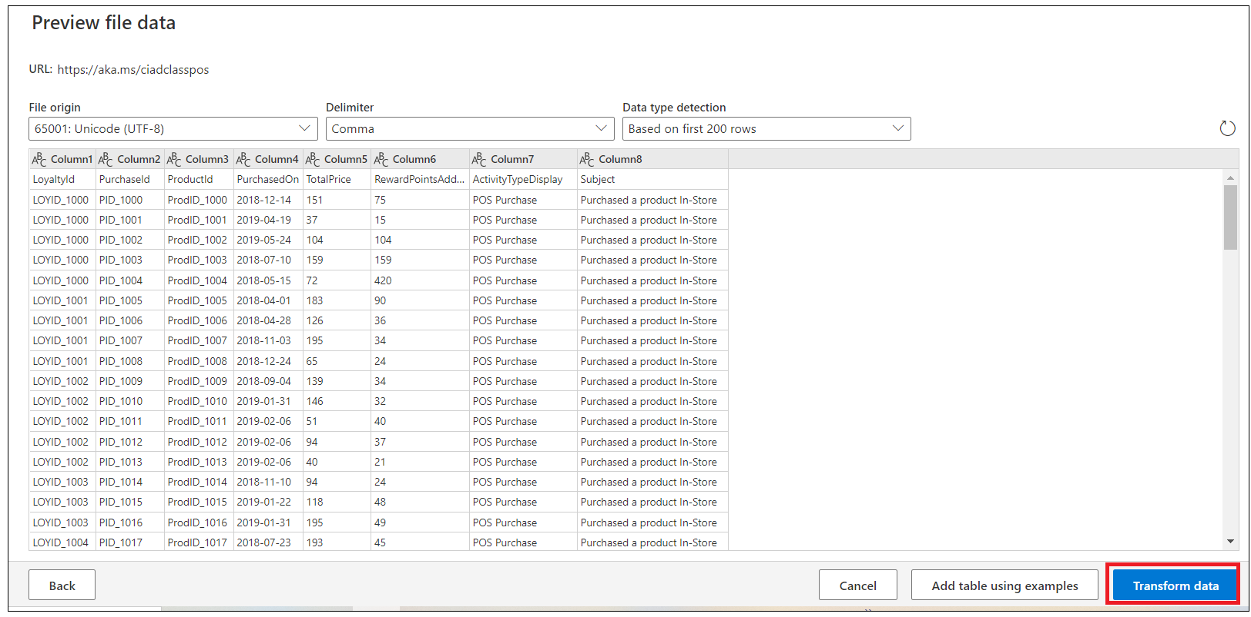

1. You should now see the data from the source tabulated. Here you can configure the datatypes and formats for the data you ingest.
2. You'll notice that the column heading has appeared in the first row of the data. To correct this, **Use First Row as Headers**.

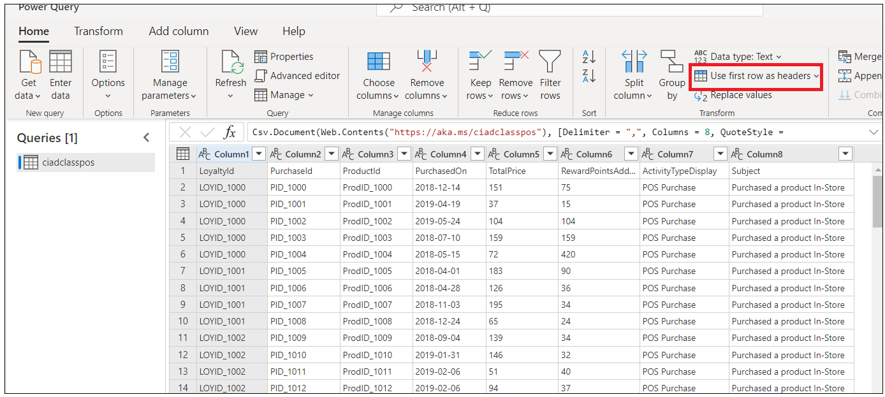

1. Because we have ingested data from a Text/CSV source, all columns have been defaulted to a ‘Text’ Data Type. To successfully ingest and model the data, we can set the datatype for non-text columns.
2. To change the datatype, select the **ABC** icon within the column heading. Update the datatype for the columns listed below.
3. Use the first row as column headings.

| **Column heading** | **New data type** |
| --- | --- |
| PurchasedOn | Date/Time/Zone |
| TotalPrice | Currency |
| RewardPointsAdded | WholeNumber |

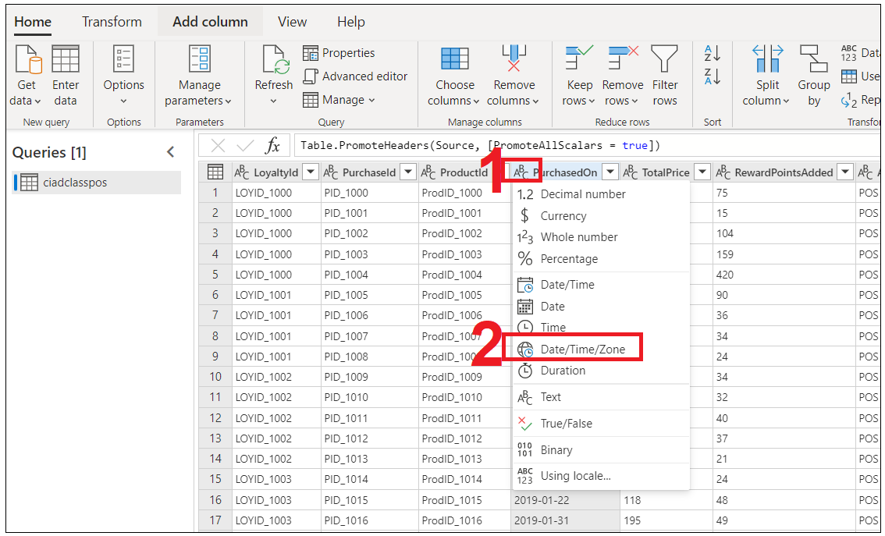

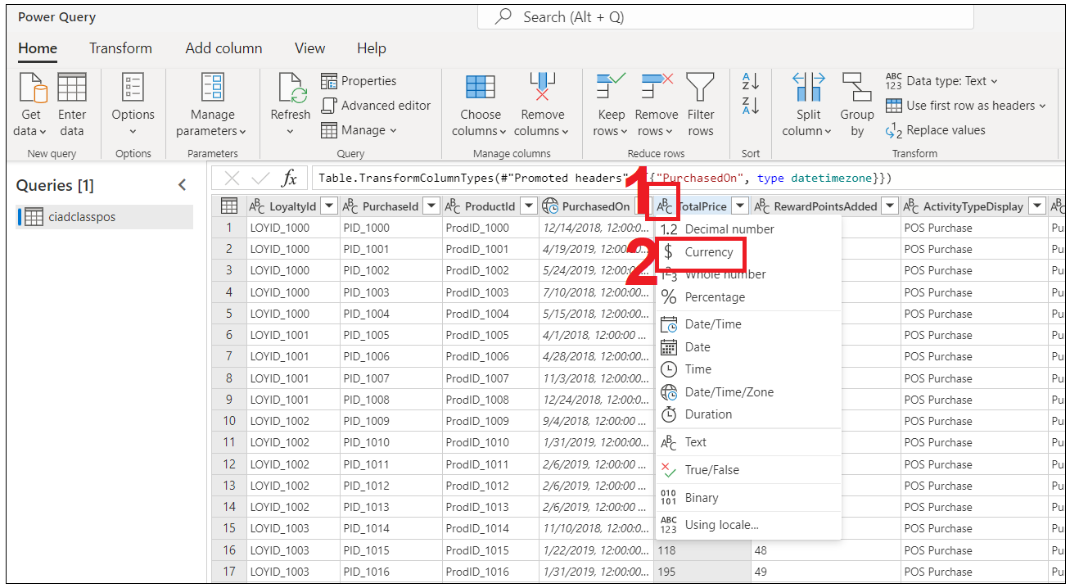

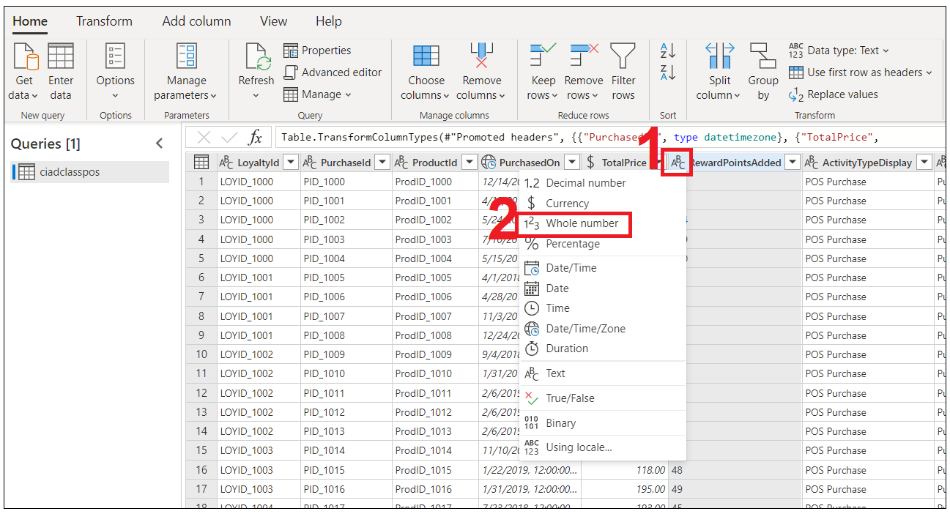

1. In the **Name** field on the right-hand pane, rename your data source from **Query** to **posPurchases** and select **Next** .

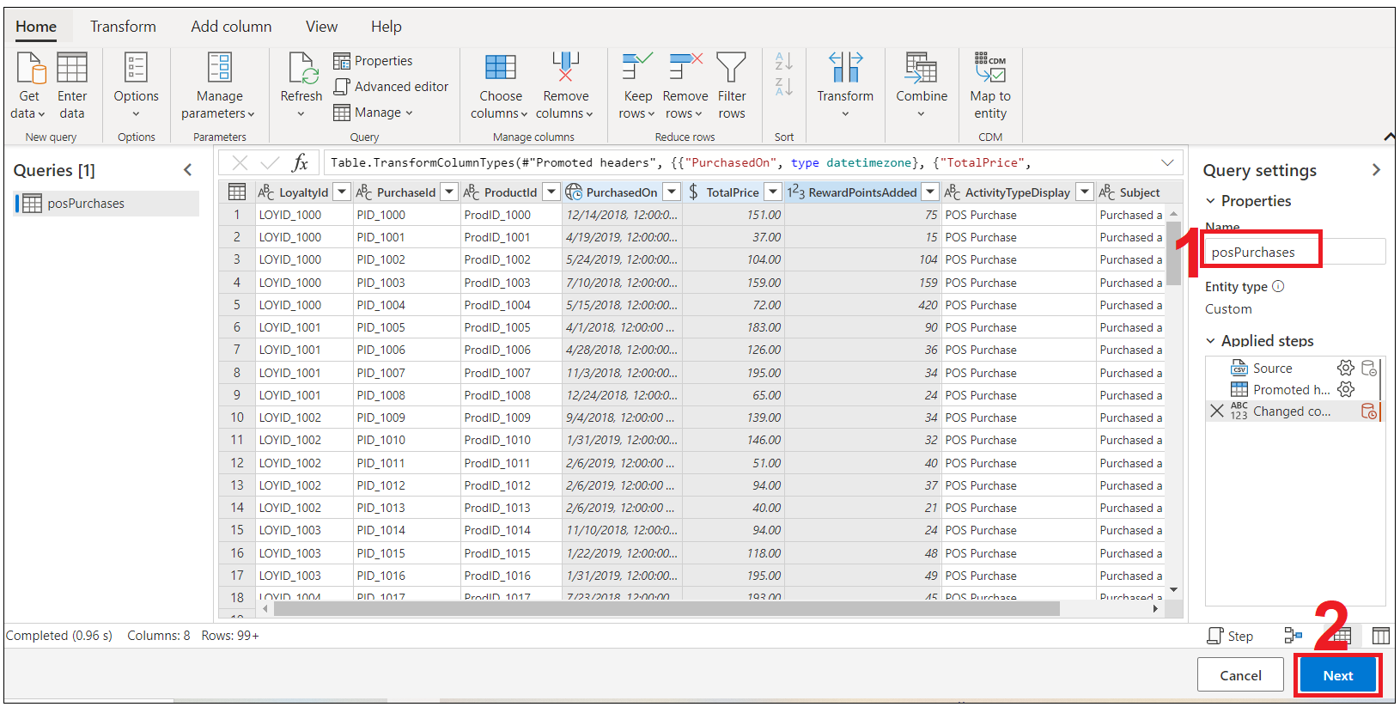

1. Select **Refresh manually** and then click on **Save**.

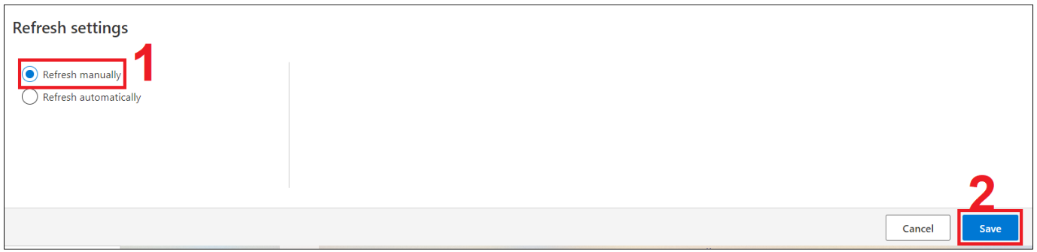

**Task 7 – Ingest Customer Data from Website Reviews**

1. Within Customer Insights, expand **Data** on the left menu and select **Data Sources**. Select **Add Data Source**.

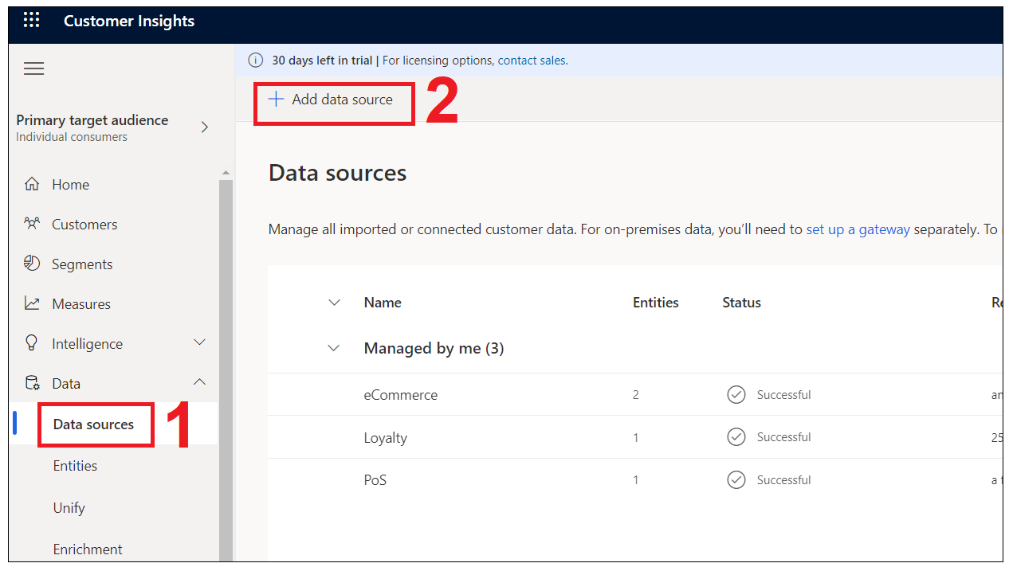

1. Select Microsoft Power Query ,Name the source **Website** then select **Next**.

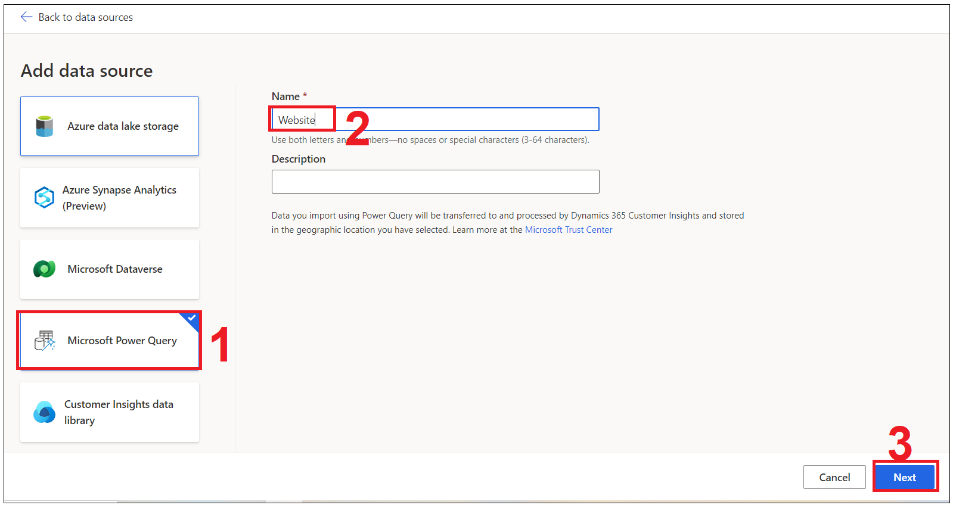

1. You'll be presented with a view of data source connectors that Customer Insights is able to ingest. Take note of the connector types available. Select the **Text/CSV** Connector.



1. Enter the URL for [Website Reviews](https://ciaddata.blob.core.windows.net/ciad-sample-data/WebsiteReviews.txt) and select **Next**.

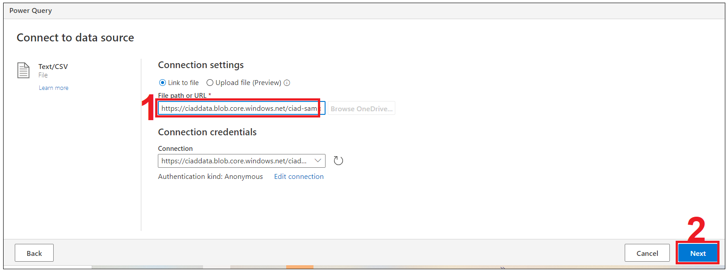

1. You'll now see the **Preview File Data** screen. Here you can change the delimiter, file origin type or what data is being used for the data type detection. You can select the **Transform data button**.

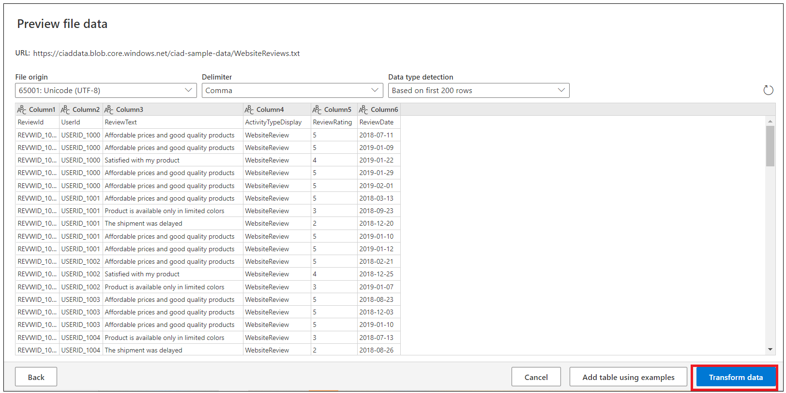

1. You should now see the data from the source tabulated. Here you can configure the datatypes and formats for the data you ingest.
2. You'll notice that the column heading has appeared in the first row of the data. To correct this, **Use First Row as Headers**.

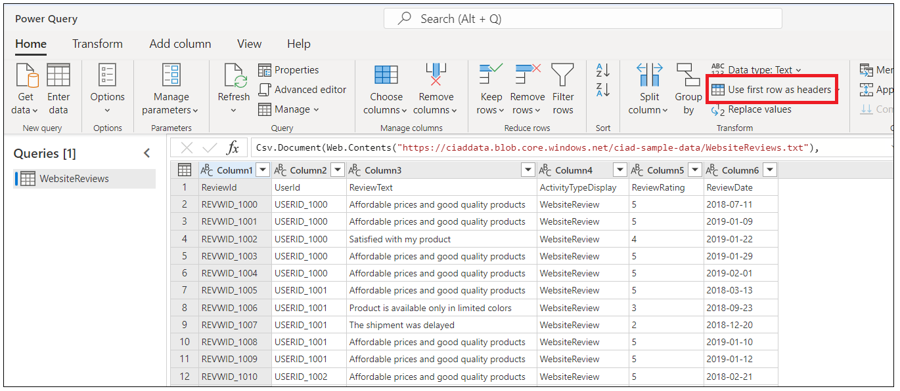

1. Because we have ingested data from a Text/CSV source, all columns have been defaulted to a ‘Text’ Data Type. To successfully ingest and model the data, we can set the datatype for non-text columns.
2. To change the datatype, select the **ABC** icon within the column heading. Update the datatype for the columns listed below.
3. Use the first row as column headings.

| **Column heading** | **New data type** |
| --- | --- |
| ReviewRating | Whole Number |
| ReviewDate | Date/Time/Zone |

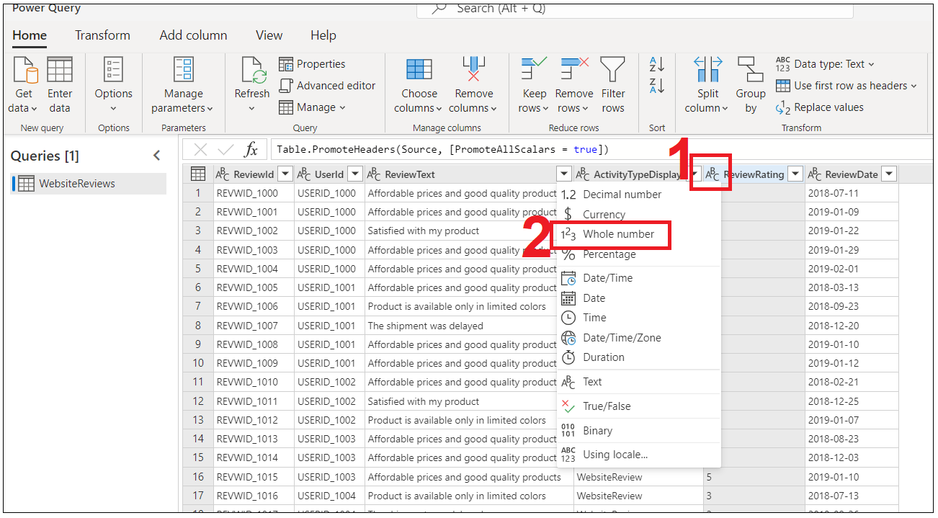

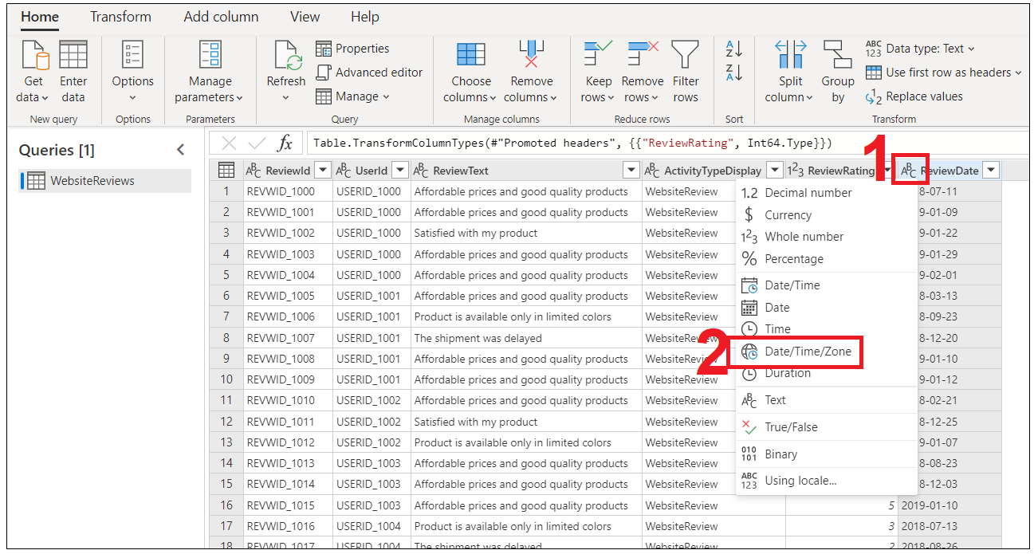

1. In the **Name** field on the right-hand pane, rename your data source from **Query** to **webReviews** and select **Next**.

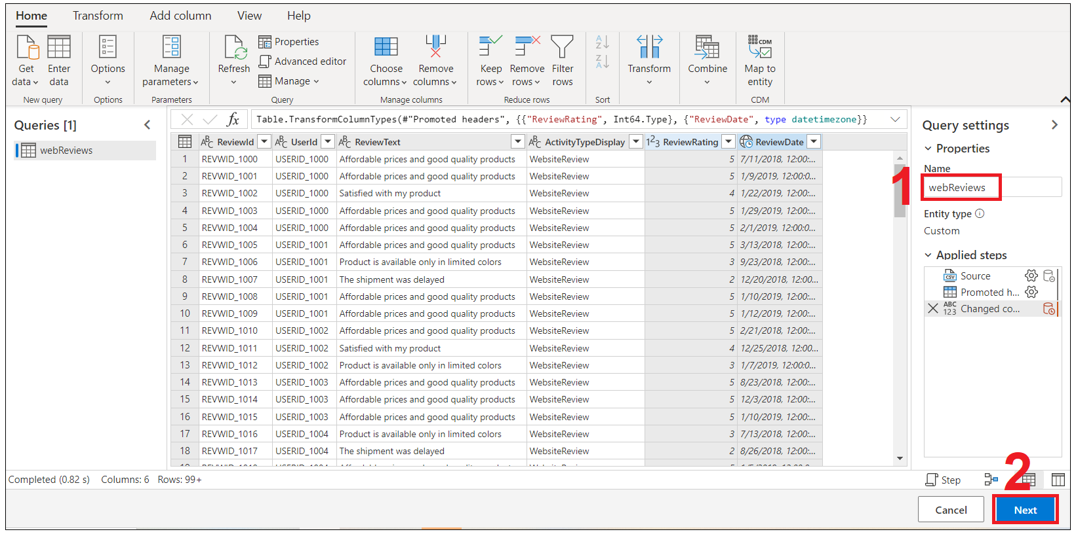

1. Select **Refresh manually** and then click on **Save**.



1. After all sources have been ingested, you should have four data sources, as shown in the following figure.

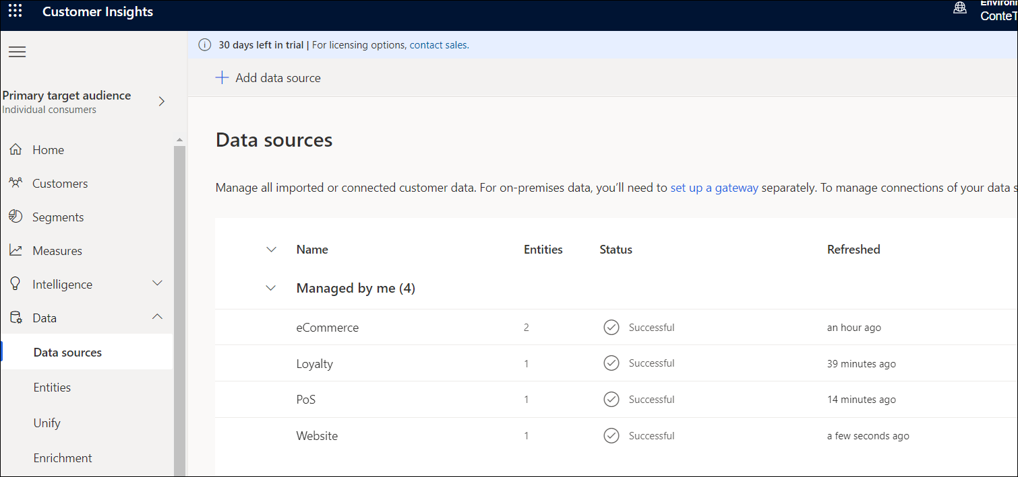

The data sources should contain the queries that are shown in the following screenshot.

**Note**

If you named your queries differently then you will need to make adjustments as you go through the content as this content assumes the naming providing in the steps above.

### Task 6 : Ingest Customer Data from Dynamics 365 Customer Engagement (Dataverse)

This exercise is to ingest the Customer Data from your Dynamics 365 Customer Engagement

1. Within Customer Insights and your environment, expand ‘**Data’** on the left menu and click **‘Data Sources’**

Click **+ Add Data Source**,

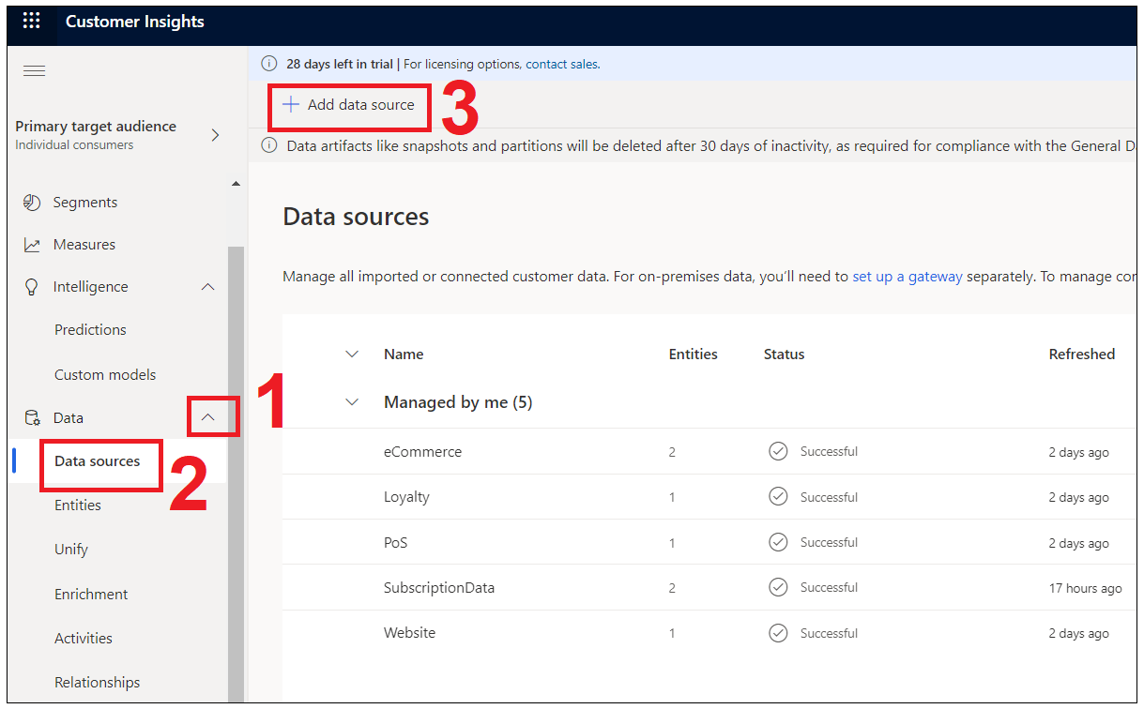

1. Choose **“Microsoft Power Query”**. Name the source ***D365DataPQ***, then click **Next**.

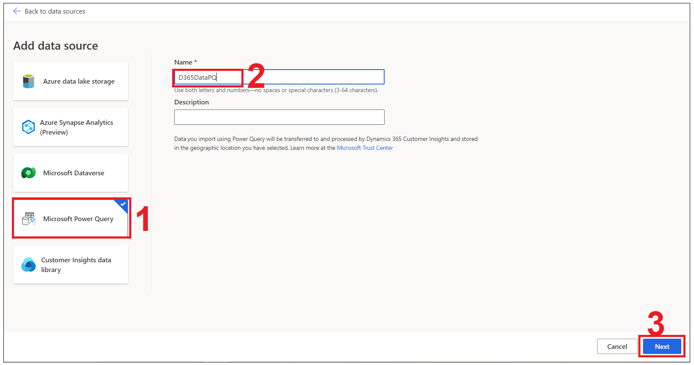

1. This time, choose “**Dataverse**” to connect to **Power Platform Dataverse** which store the **Dynamics 365 Data** too.

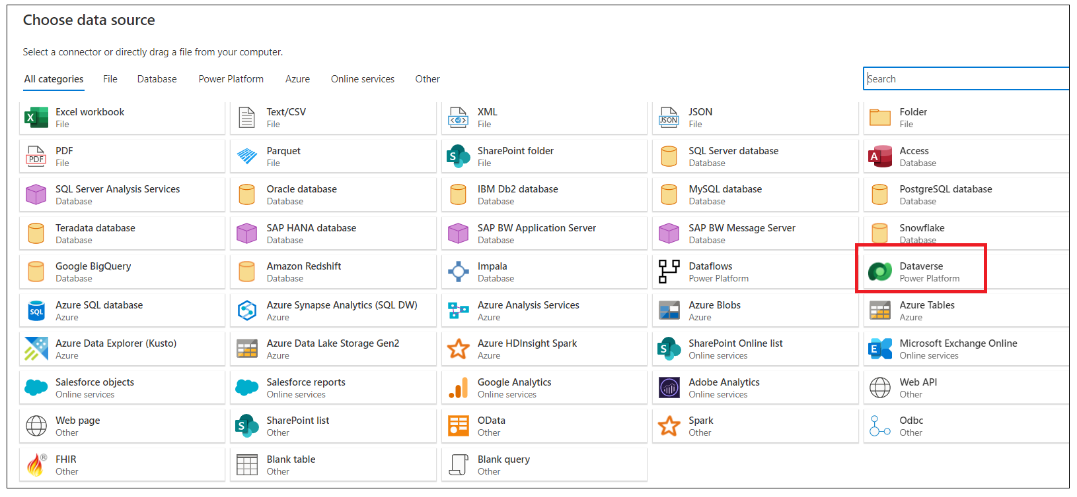

1. Leave the server URL address **blank**. Leaving the address blank will list all the available environments you have permission to use in the Power Query Navigator window. Then, **Sign In** and key in your Admin credential.

**Username :** [**admin@MXXXXX.onmicrosoft.com**](mailto:admin@MXXXXX.onmicrosoft.com)

**Password : XXXX**

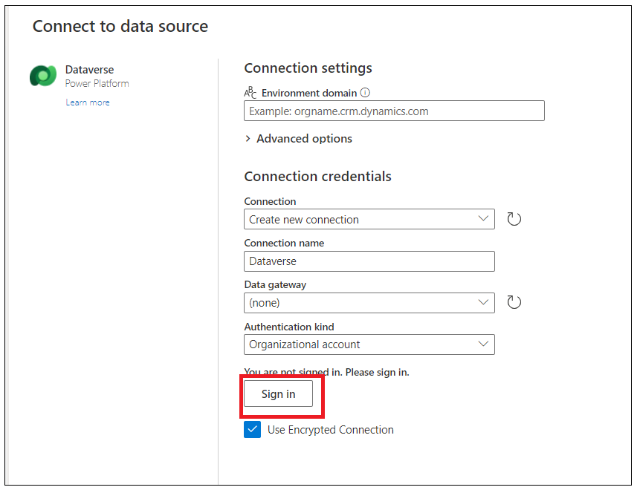

**Note** : make sure you unblock pop-ups.

1. After you have successfully signed in, Click on **Next**.

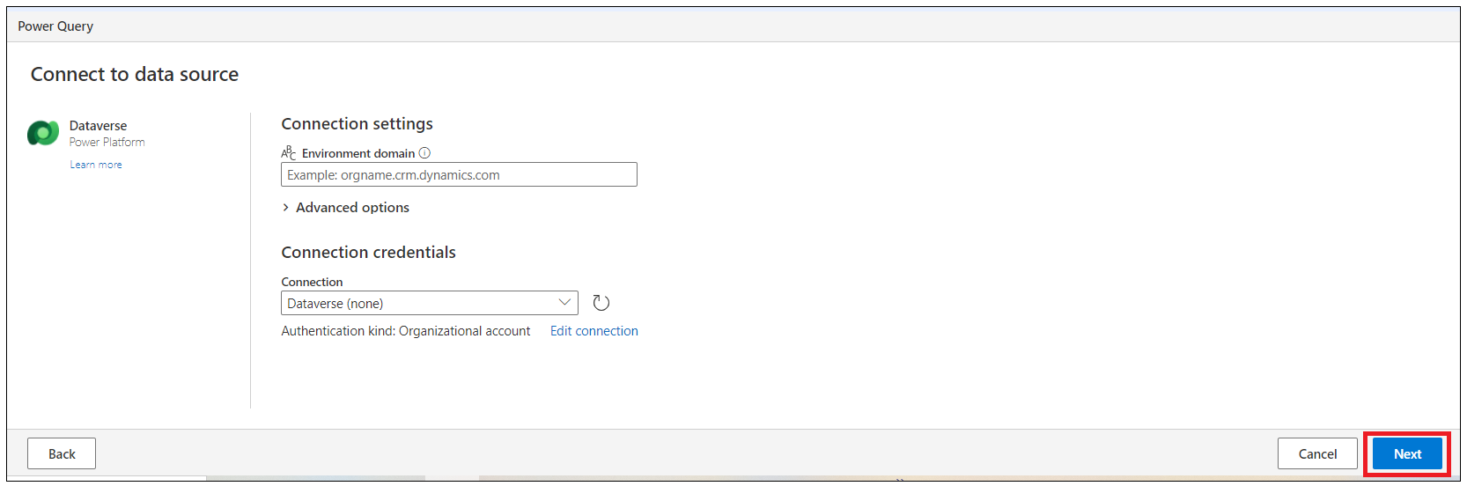

1. You will see the list of environments you have access, then choose your **Dynamics 365 environment** that has been created for you.
2. Select your dataverse environment and then click on Refresh as shown in below image.Click **Configure connection button** at the top right corner.

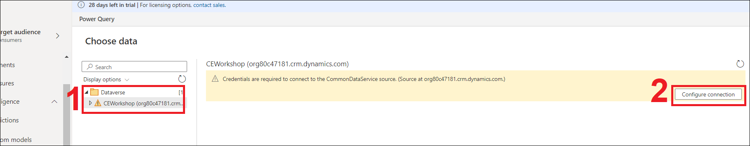

1. Click on **Sign-in** and sign in with your Office 365 tenant credentials

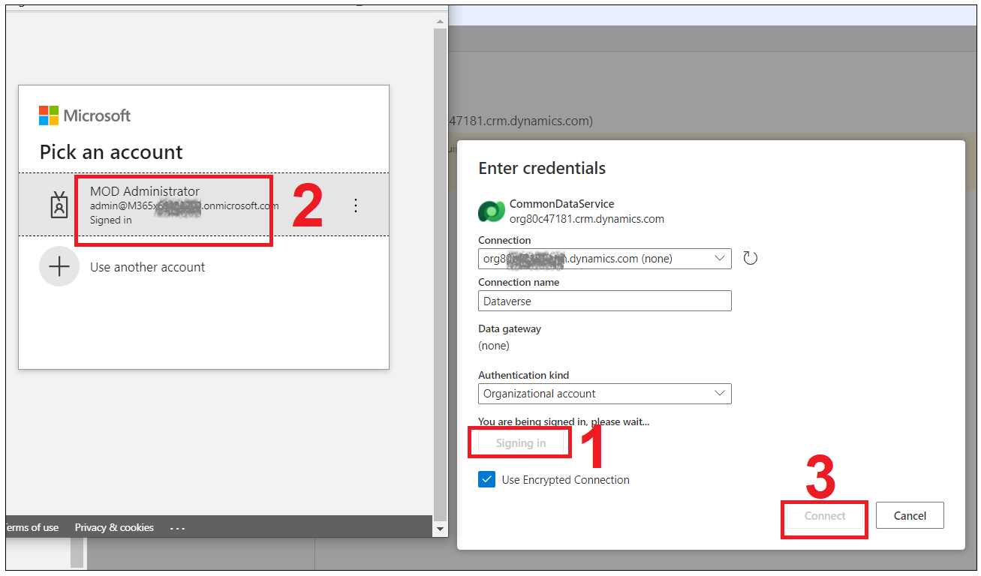

1. Then, you can choose existing connection and click **Connect**.

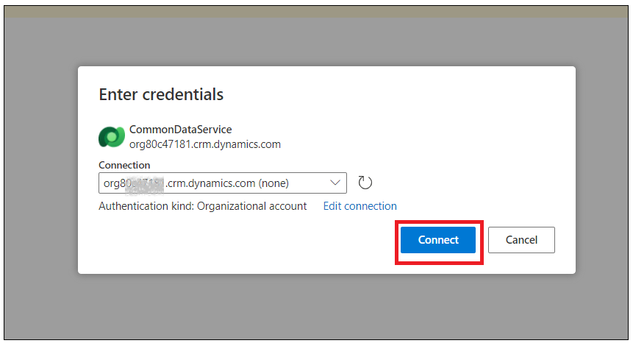

1. After you successfully connected, then you can choose tables to be included in CI, in this lab, please choose:

**Account, Contact, Product, and Incident** and then, click **Transform Data**.

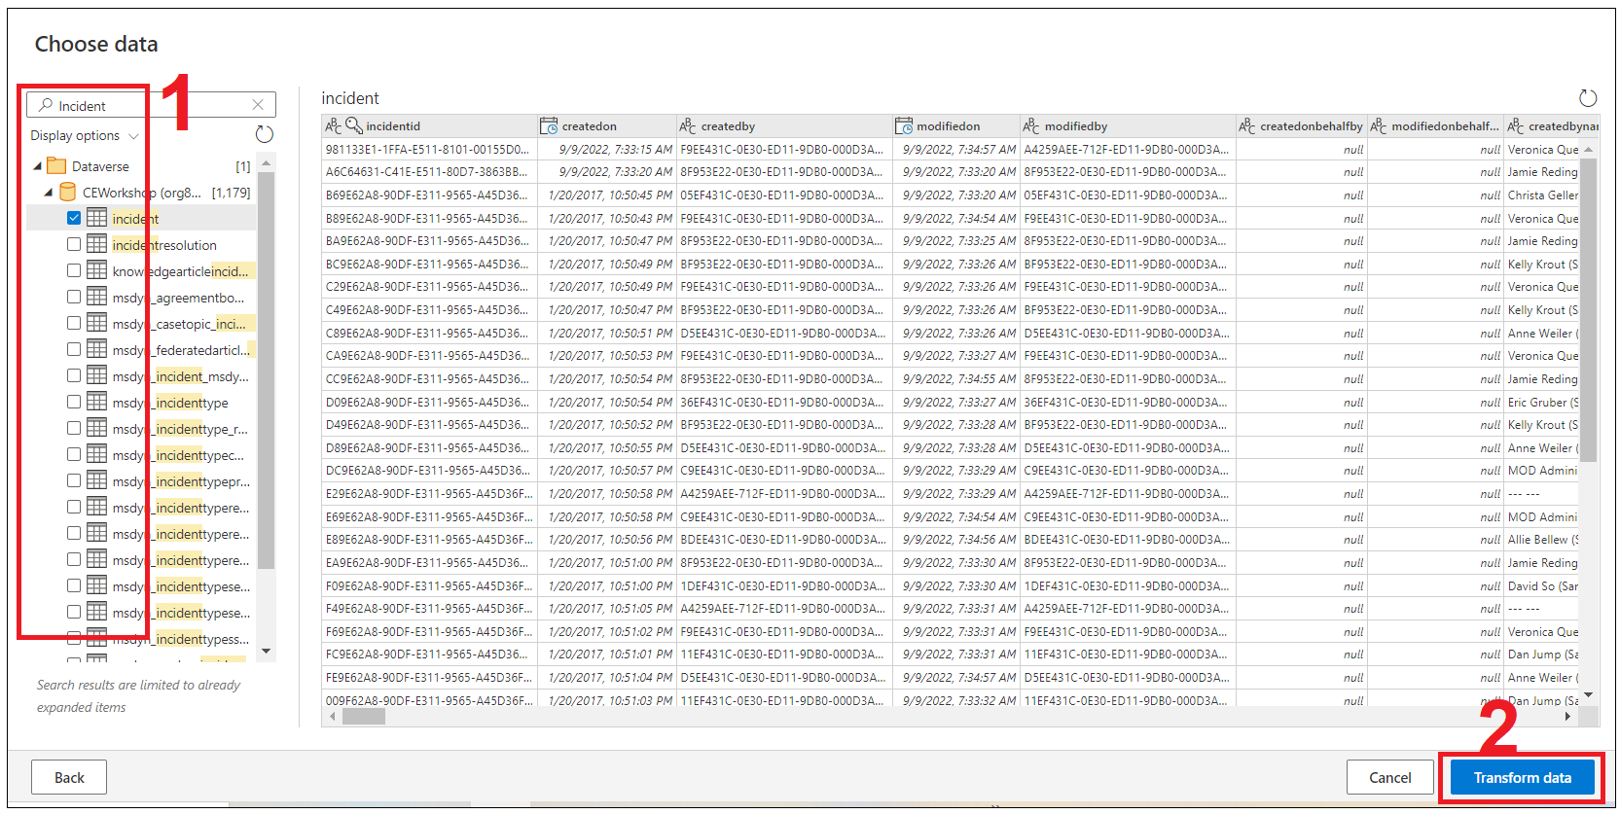

1. You will see the four entities/tables you have chosen in earlier step.

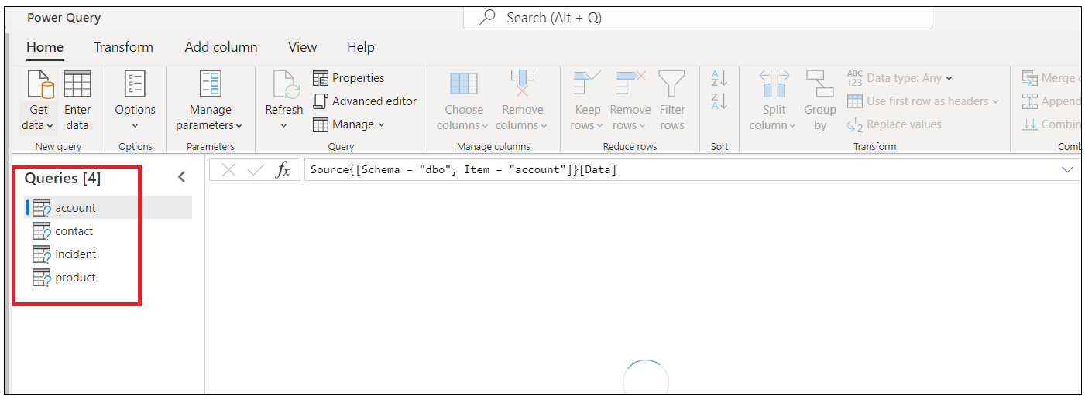

1. In the **Transform Data** part, you are going to choose columns for each table to be included to avoid any unnecessary data being retrieved and stored in **Customer Insight Entities** that can make it looks like ‘**crowded’**.
2. For each table, choose the table in the left side and then click the **Choose columns**.

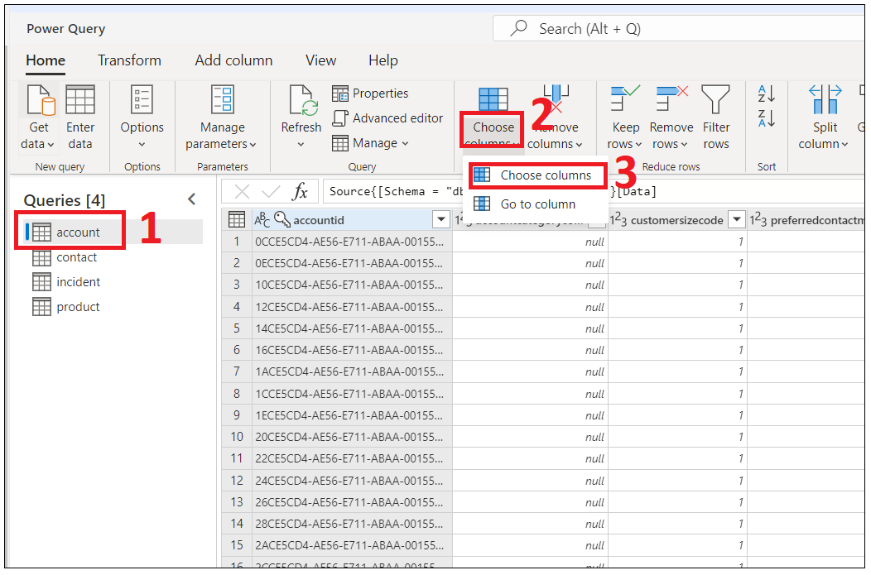

1. For **Account**, please search and select the columns below and click on **OK**.
   * 1. ***Accountid***
     2. ***Accountratingcodename***
     3. ***Name***
     4. ***Accountnumber***
     5. ***Createdon***
     6. ***address1_line1***
     7. ***address1_city***
     8. ***address1_country***
     9. ***industrycodename***
     10. ***statecodename***
     11. ***statuscodename***

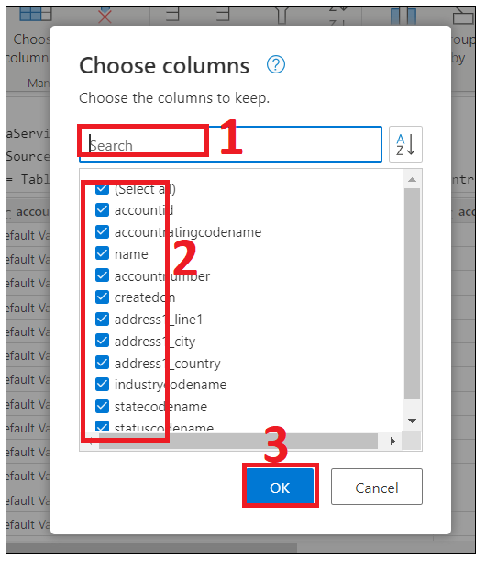

Or

Updated ComoomDataservice.Database( Your Dataverse server name ) and paste the formula and press enter

let

  Source = CommonDataService.Database("[orgb2d80f9f.crm.dynamics.com](https://orgb2d80f9f.crm.dynamics.com/)"),

  #"Navigation 1" = Source{[Schema = "dbo", Item = "account"]}[Data],

  #"Choose columns" = Table.SelectColumns(#"Navigation 1", {"accountid", "accountratingcodename", "name", "accountnumber", "createdon", "address1_line1", "address1_city", "address1_country", "industrycodename", "statecodename", "statuscodename"})

in

  #"Choose columns"

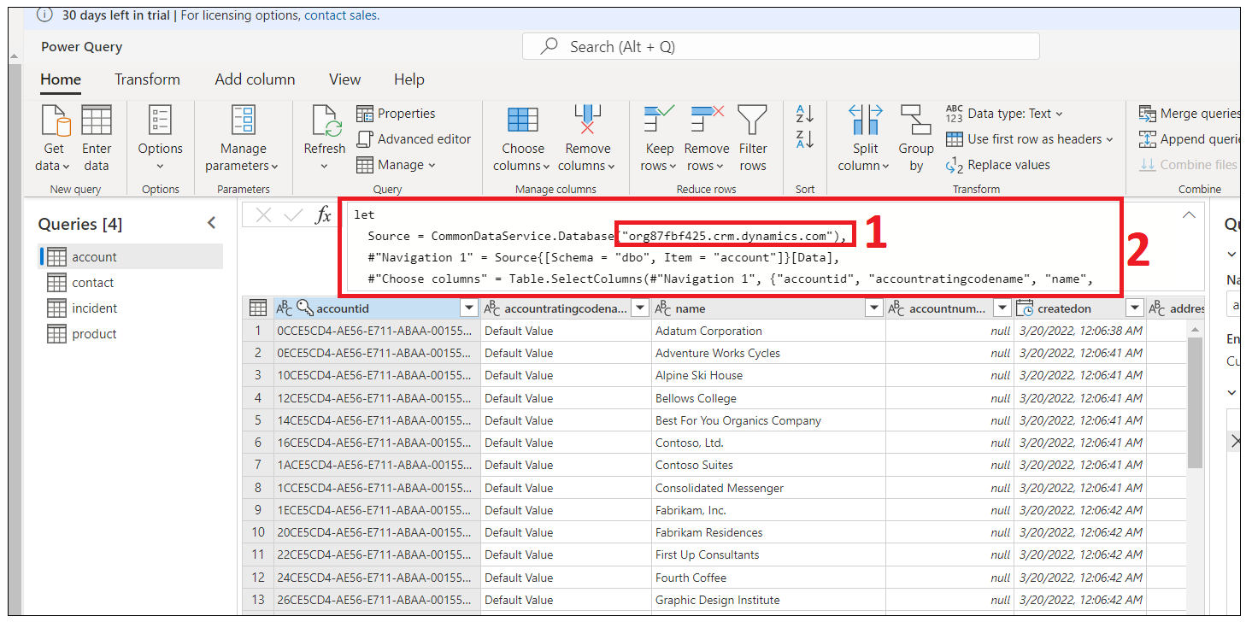

or

Note ‘ Alternatively, you can just copy paste the formula expression:

Table.SelectColumns(#"Choose columns", {"accountid", "accountratingcodename", "name", "accountnumber", "createdon", "address1_line1", "address1_city", "address1_country", "industrycodename", "statecodename", "statuscodename"})

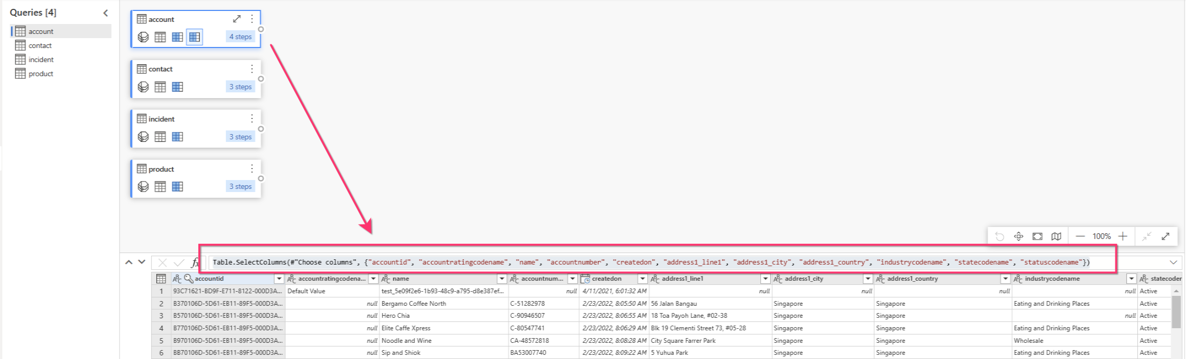

1. For **Contact**, Click on **Choose columns ->Choose columns**.

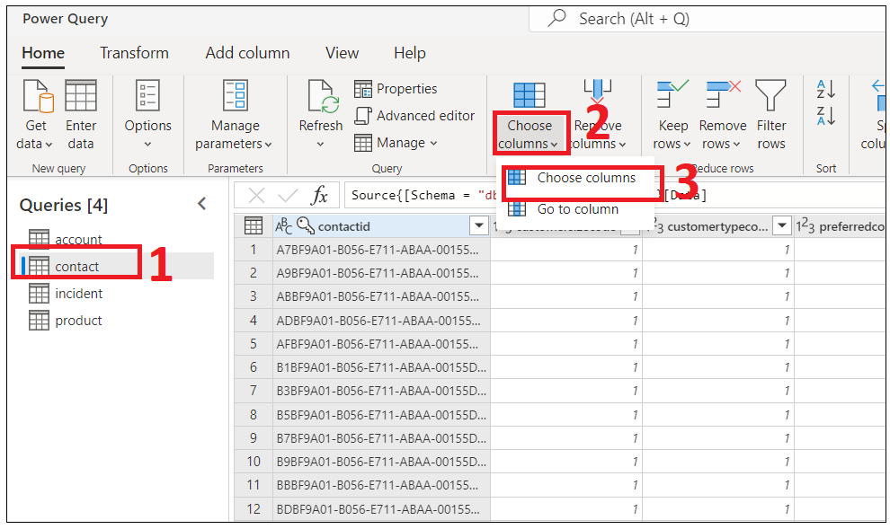

* + 1. Search and select below columns and then click on **Ok**.
    2. contactid
    3. accountid
    4. Jobtitle
    5. Firstname
    6. Middlename
    7. Lastname
    8. Fullname
    9. Birthday
    10. emailaddress1
    11. donotemail
    12. createdon
    13. mobilephone
    14. address1_line1
    15. address1_city
    16. address1_country
    17. address1_telephone1
    18. gendercodename
    19. parentcustomerid
    20. parentcustomeridname

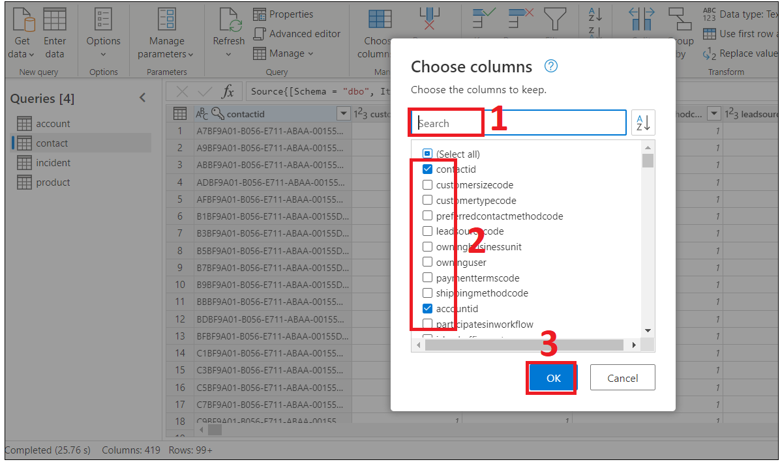

Alternatively, you can just copy paste the formula expression:

Table.SelectColumns(#"Navigation 1", {"contactid", "accountid", "jobtitle", "firstname", "middlename", "lastname", "fullname", "birthdate", "emailaddress1", "donotemail", "createdon", "mobilephone", "address1_line1", "address1_city", "address1_country", "address1_telephone1", "gendercodename", "parentcustomerid", "parentcustomeridname"})

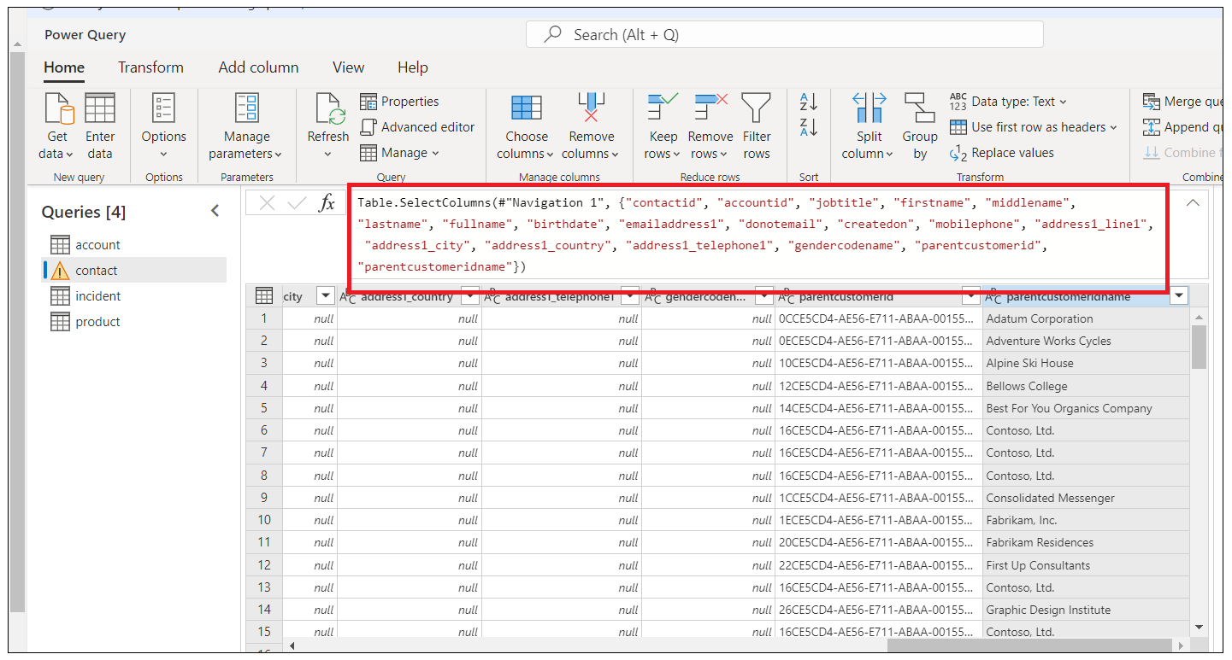

Or

let

  Source = CommonDataService.Database("**org87fbf425.crm.dynamics.com**"),

  #"Navigation 1" = Source{[Schema = "dbo", Item = "contact"]}[Data],

  #"Choose columns" = Table.SelectColumns(#"Navigation 1", {"contactid", "accountid", "jobtitle", "firstname", "middlename", "lastname", "fullname", "birthdate", "emailaddress1", "donotemail", "createdon", "mobilephone", "address1_line1", "address1_city", "address1_country", "address1_telephone1", "gendercodename", "parentcustomerid", "parentcustomeridname"})

in

  #"Choose columns"

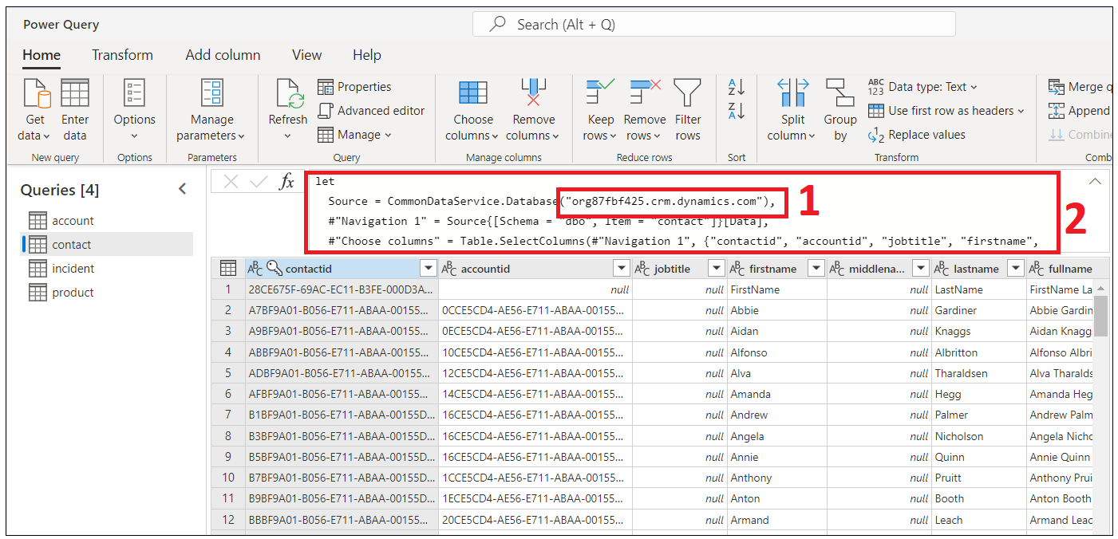

1. For **Incident**, click on **Choose columns -> Choose columns**

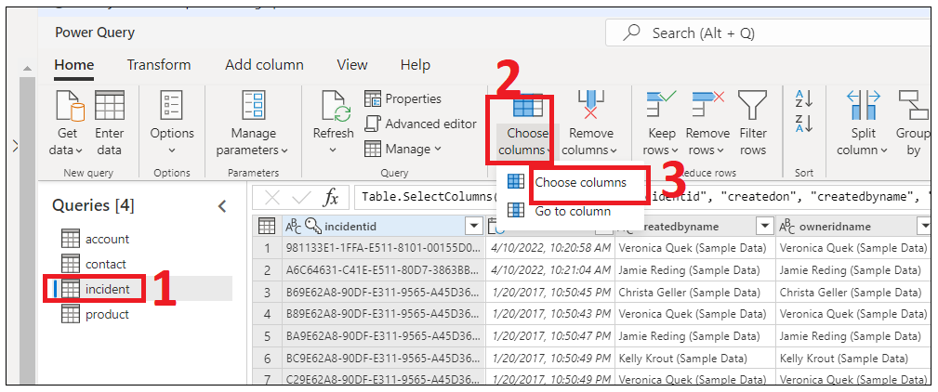

* + 1. Search and select the below columns ( or paste any one of the formulas mentioned below to select columns) and then click on **OK**.

Incidentid

Contactid

createdon

createdbyname

owneridname

title

caseorigincodename

casetypecodename

description

prioritycodename

statecodename

statuscodename

customerid

customeridname

productidname

subjectidname

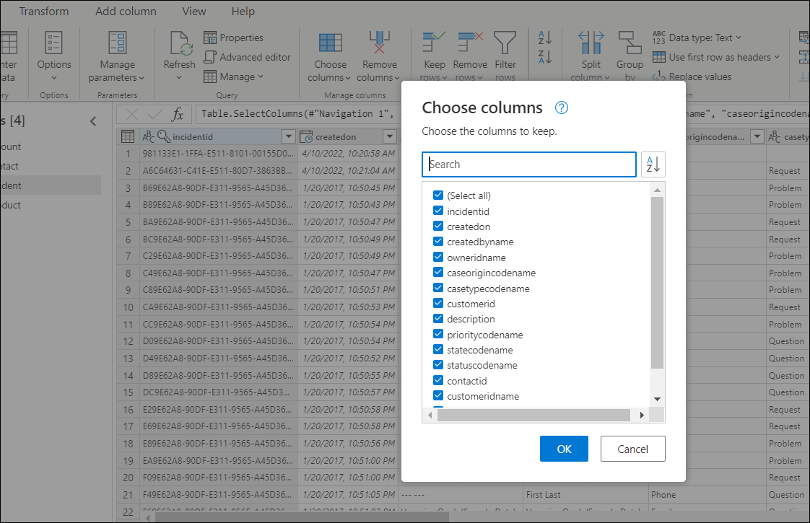

Alternatively, you can just copy paste the formula expression:

Table.SelectColumns(#"Navigation 1", {"incidentid", "createdon", "createdbyname", "owneridname", "title", "caseorigincodename", "casetypecodename", "customerid", "description", "prioritycodename", "statecodename", "statuscodename", "contactid", "customeridname", "productidname", "subjectidname"})

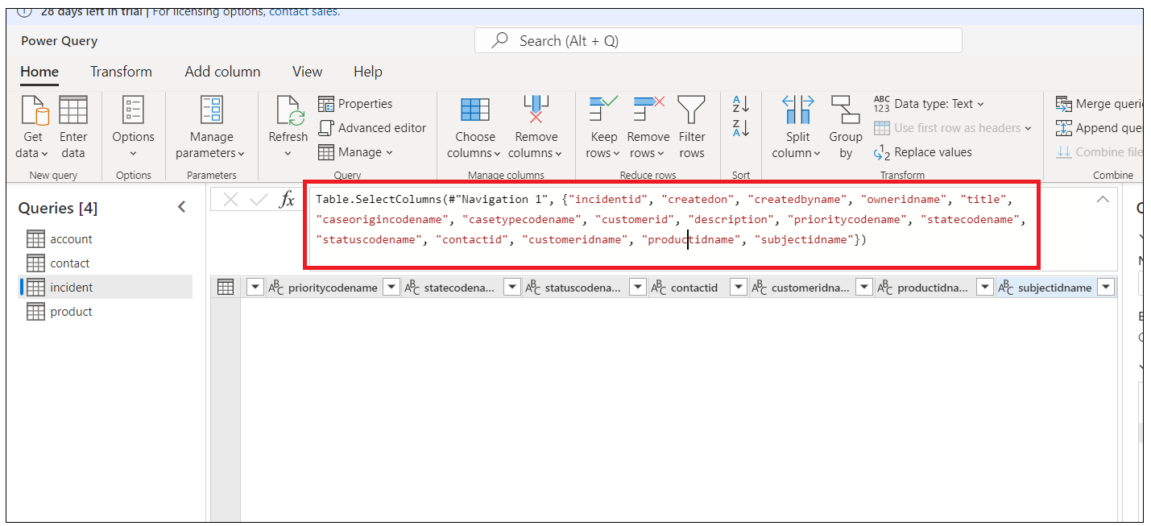

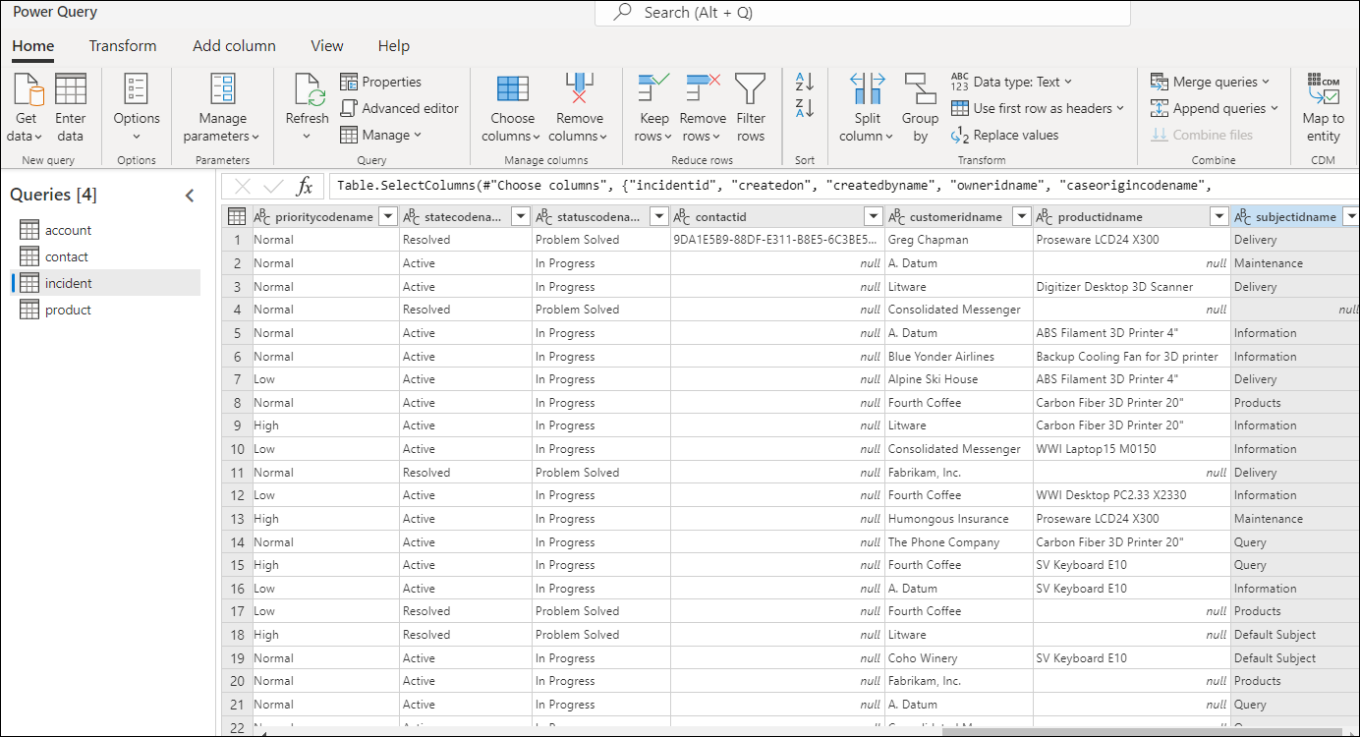

1. For **Product**, please select the columns below:

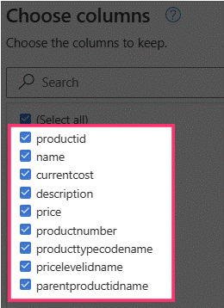

Alternatively, you can just copy paste the formula expression:

Table.SelectColumns(#"Navigation 1", {"productid", "name", "currentcost", "description", "price", "productnumber", "producttypecodename", "pricelevelidname", "parentproductidname"})

1. Click on **Next**.

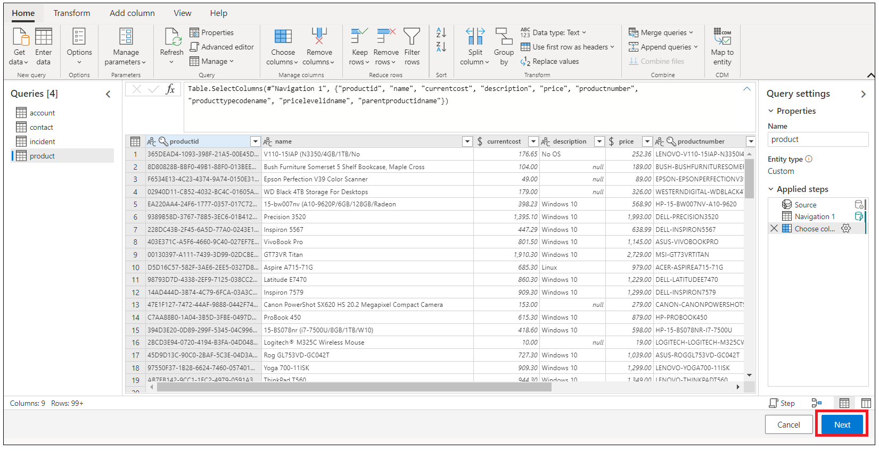

1. Select **Refresh manually** and then click on Save**.**

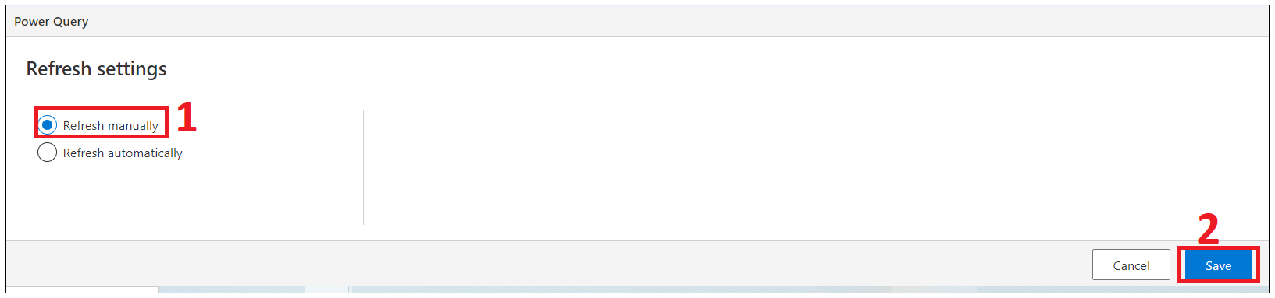

Note : If you see below error then go back to Datasource and select your data source then click on **Refresh**

1. Here is the list of data sources you have created. Congratulations!

